Findings and Recommendations
on the Resource Needs of
California’s Urban Search and Rescue Teams

A Report of the
Urban Search and Rescue Emergency Advisory Committee

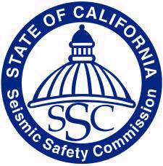

California Seismic Safety Commission
1755 Creekside Oaks Drive, #100
Sacramento, California 95833

Commission Publication No. 03-05
September 2003
California Seismic Safety Commission

Stan Y. Moy Dr. Lucile M. Jones Andrew A. Adelman
Chairman Vice Chair Cities/Building Official
Architectural Planning Seismology

Hon. Richard Alarcon James Beall Mark Church
Alternate: Chris Modrzejewski County Government Local Government
State Senate

Dr. Bruce R. Clark Lawrence Klein Hon. Carol Liu
Geology Utilities Alternate: Don Manning
State Assembly

Linden Nishinaga Celestine Palmer Donald R. Parker
Cities Government Insurance Fire Protection

Daniel Shapiro Jimmie R. Yee
Structural Engineering Social Services

California Seismic Safety Commission Staff

Richard J. McCarthy Henry Sepulveda
Executive Director Project Manager

Robert Anderson Sue Celli Karen Cogan
Henry Reyes Fred Turner

Interns
Abby Browning
Kyshia Davis
Adam Myers
Dedication

Raymond M. Downey, a Deputy Chief for the Fire Department of the City of New York is recognized as the “Father” of modern Urban Search and Rescue techniques.

In March 1998, Chief Downey testified before Congress about the first attack on the World Trade Center. Requesting additional funding for Urban Search and Rescue, at that hearing he said

…We, the fire service, are no better prepared then we were back in 1995. Why? The training that has been given with federal funding is not being directed to the “first responder,” and the lack of providing funding for the necessary equipment for these responders is directly related to the lack of our preparedness.
…The first responders, the firefighters...performed heroic actions only because they were able to be on the scene within minutes and were properly trained and equipped.

Chief Downey died in the September 11, 2001 attacks on the World Trade Center.

The Urban Search and Rescue Emergency Advisory Committee of the California Seismic Safety Commission proudly dedicates this report in honor and in the memory of Deputy Chief Ray Downey.

Executive Summary

On September 11, 2002, AB 2002 (Alquist) was signed into law establishing the Urban Search and Rescue Emergency Advisory Committee. Guided by the California Seismic Safety Commission and in consultation with the Governor’s Office of Emergency Services, the Committee was directed to prepare a strategy, plan and recommendations addressing the resource needs of emergency urban search and rescue teams in California.

After reviewing extensive information, accepting testimony from experts and evaluating on-site demonstration, the Committee, consisting of experienced professionals in the fields of firefighting, law enforcement, and Urban Search and Rescue, developed findings and recommendations to address the resource needs of State and local Urban Search and Rescue (US&R) task forces.

The Committee’s findings include:
- It is imperative for public health and safety that trained and equipped local US&R first-responders are available for emergency response throughout the state;
- Local US&R units are vulnerable to local-area disasters (such as earthquakes) and could be compromised in their capabilities to deliver prompt life-saving services;
- Local governments alone cannot shoulder the financial burden of developing and maintaining the needs of local US&R resource teams;
- The benefits of well-maintained and equipped local US&R resource teams extend to regional and State jurisdictions;
- Emergency response equipment being utilized by many local agencies is aging and less effective than newer equipment; and
- Emerging technological advances are continuing to develop emergency response equipment that is more effective and efficient, yet costly to local governments.

The Committee recommends:
- Active and expanded support for the improvement and expansion of local US&R teams;
- Immediate and aggressive pursuit of funding from federal, state and other public or private sources to finance the acquisition of vehicles and equipment, the construction and improvement of training facilities, and the expansion of specialized training;
- Development of a detailed, multi-year master plan and timeline for the acquisition of the vehicles and equipment, the construction and improvement of training facilities, and the expansion of specialized training; and
- Establishment of an US&R Oversight Committee to supervise the State’s efforts to carry out these recommendations in a timely, cost-effective and expedited manner.
California Seismic Safety Commission

Urban Search and Rescue
Emergency Advisory Committee Report

Findings and Recommendations
on the Resource Needs of
California’s Urban Search and Rescue Teams

Purpose of Report 6

Legislation and Policy Background 7

California Master Mutual Aid Agreement and
Urban Search and Rescue Resources 9
Inventory of Existing Resources 17

Assessment of Urgency 20

Current Needs and Rationale 23

Future Influences 27

Findings 28

Recommendations 29

Appendix 28
Urban Search and Rescue Emergency Advisory Committee
Presentations Made to the Committee
Glossary
Calculations of Training Costs
Purpose of Report

This Report was prepared and is submitted to comply with the requirements of Chapter 460, Statutes of 2002 (AB 2002, Alquist). That legislation (codified as Section 8601 of the Government Code) directs the Seismic Safety Commission to convene an Urban Search and Rescue Emergency Advisory Committee to prepare a strategy, plan and recommendations addressing the resource needs of emergency urban search and rescue teams in California.

Government Code Section 8601 requires the Committee to consult with the Governor’s Office of Emergency Services and to submit its final report to the Commission by September 1, 2003.

US&R Rescue Personnel at WTC Disaster site
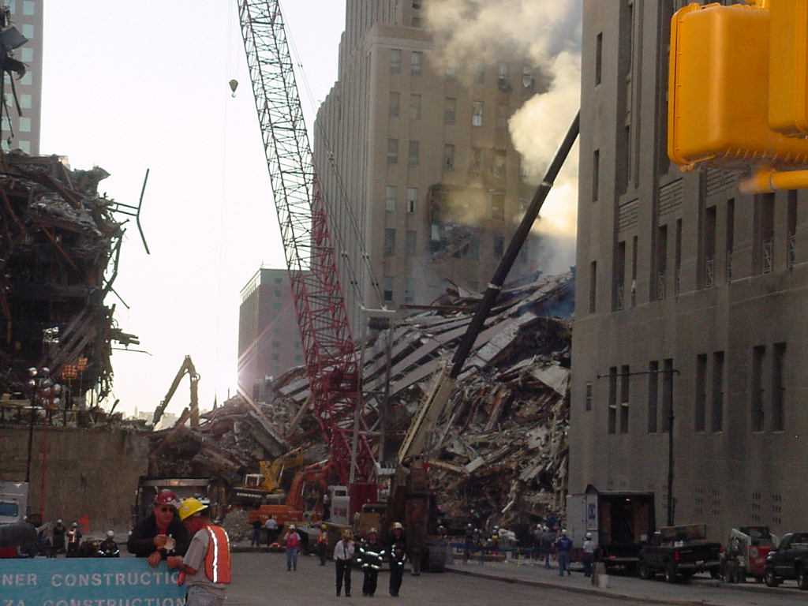

Legislation and Policy Background

In enacting AB 2002, the Legislature found:

- The ability of emergency response agencies, particularly those operating under mutual-aid agreements, to respond expeditiously and effectively during disaster situations is critical to saving lives and preserving property;

- To maintain an effective response capability, there is a need for a coordinated planning strategy to address the ongoing resource needs of emergency response agencies, including urban search and rescue units.

- The emergency response equipment being utilized by many local agencies is aging, and less effective than newer equipment being developed and made available to local emergency response agencies.

- Emerging technological advances are continuing to develop emergency response equipment that is effective and efficient, yet costly to local government agencies.

Consequently, the approval of AB 2002 signaled that the Legislature and Governor agreed that it is necessary for the state, as part of the statewide mutual-aid agreement and arrangements, and in the interest of protecting the lives and property of its residents, to assist local agencies with the planning resources affecting mutual-aid units. Specifically, that assistance should enable mutual-aid units to maximize their effectiveness in responding to and managing emergencies faced by the state, as well as local and regional communities.

In addition, the California Earthquake Loss Reduction Plan, 2002-2006, the State’s official earthquake recovery management strategy, calls for the statewide improvement of urban search-and-rescue units. According to the Plan, the improvement of the urban search-and-rescue units should be a priority for the State’s emergency management and response infrastructure. Specifically, the Plan recommends that the State of California:

- Establish and maintain strategically located urban search and rescue training facilities that are properly equipped and staffed to provide real-time preparedness training for emergency response personnel.

- Ensure that all teams have a complete cache of specialized urban search and rescue equipment (emphasis added).

- Provide adequate resources for maintenance and replacement of specialized urban search and rescue equipment cache.

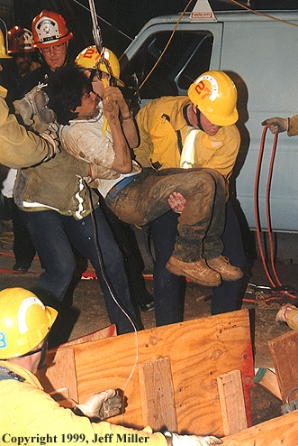
US&R workers extricate worker from collapsed trench.

California Master Mutual Aid Agreement and
Urban Search and Rescue Resources

California Master Mutual Aid Agreement

Fire departments throughout the nation vary in their abilities to respond to a full range of emergencies. Mutual Aid provides for outside assistance when conditions exceed the capacity or capability of the services, personnel, or equipment of an affected jurisdiction. Whether a department has the resources to handle all emergency situations, needs mutual aid, or requires the assistance from other departments will depend on several factors, such as the:
- Magnitude or severity of the emergent situation or incident;
- Size of the department;
- Response capabilities of the department;
- Level of non-fire department resources available to the department; and
- Impact of the disaster on its own resources.

In the case of a significant earthquake, the distance from the epicenter is a major factor. Emergency response resources closest to the epicenter will likely receive the most damage and may have limited response capabilities. Damage to buildings, apparatus, and transportation arteries will certainly impede emergency responders.

The vehicle for providing mutual aid among local governments and the State is the California Master Mutual Aid Agreement. It establishes responsibilities, procedures and implementation by which many fire, rescue and other agencies throughout the State receive and render aid. Under the terms of the California Master Mutual Aid Agreement, no fire department shall be required to unreasonably deplete its own resources in furnishing mutual aid. The Master Mutual Aid Agreement is administered through the California Governor’s Office of Emergency Services (OES).

The Master Mutual Aid Agreement provides that all of its signatories will provide or receive fire or rescue aid, as needed. This interchange of resources is on a local, regional, State, and interstate basis.

Under the State’s Master Mutual Aid system, the State of California is divided into six Mutual Aid regions. Within each region are 5-16 operational areas. Each of the State’s 58 counties is considered an Operational Area and is geographically located in a region for mutual aid coordination.

Figure 1 shows the existing regions of the California Master Mutual Aid System, as designed and under the supervision of the Governor’s Office of Emergency Services.
Figure 1
California Master Mutual Aid System Regions
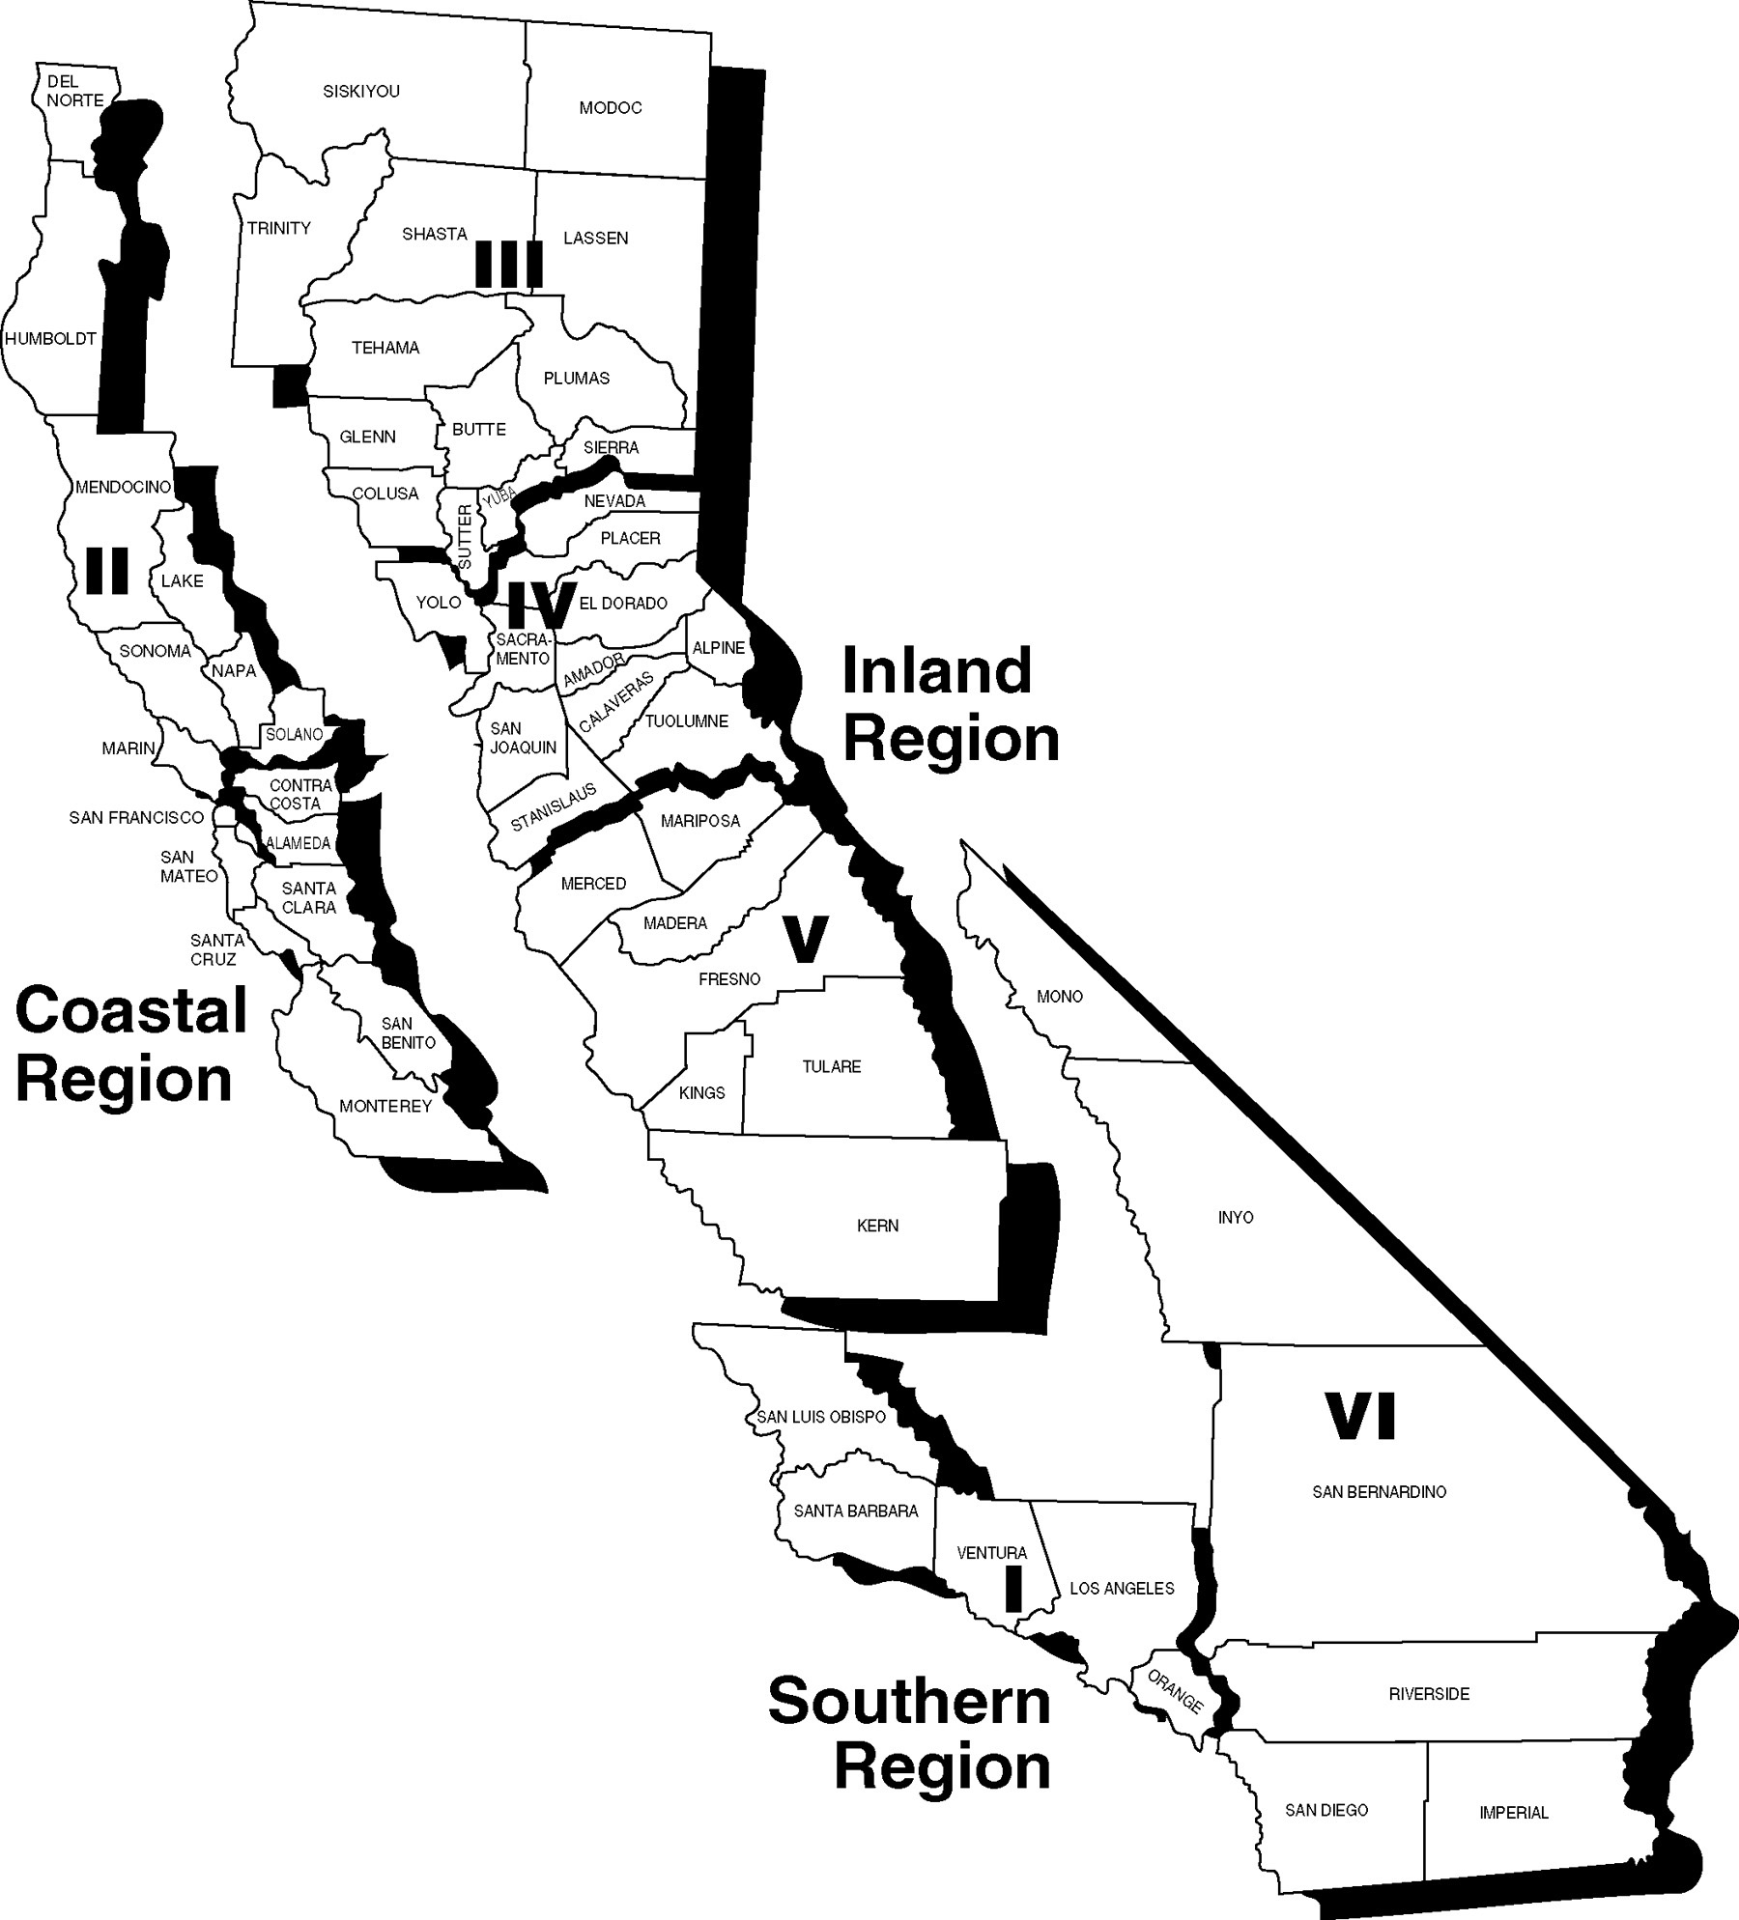

Local Urban Search and Rescue Resources

The California OES Fire and Rescue Branch categorizes local urban search and rescue resources. The Urban Search and Rescue Operational System Description identifies the four category types as Basic, Light, Medium and Heavy. Each of the four types represents a minimum capability to conduct safe and effective search and rescue operations at structure collapse or failure incidents and other emergencies where specialized rescue equipment and technical expertise are required.

The US&R Type-4 “Basic” Operational Level includes the equipment and personnel to conduct safe and effective search and rescue operations at incidents involving non-structural entrapment in non-collapsed structures.

The US&R Type-3 “Light” Operational Level includes equipment and personnel to conduct safe and effective search and rescue operations at structure collapse incidents involving the collapse or failure of Light Frame Construction and/or low angle or one person load rope rescue.

The US&R Type-2 “Medium” Operational Level includes equipment and personnel to conduct effective search and rescue operations at structure collapse incidents involving the collapse or failure of Heavy Wall Construction, high angle rope rescue (not including highline systems), confined space rescue (no permit required), and trench and excavation rescue.

The US&R Type-1 “Heavy” Operational Level includes equipment and personnel to conduct safe and effective search and rescue operations at structure collapse incidents involving the collapse or failure of Heavy Floor, Pre-cast Concrete and Steel Frame Construction, high angle rope rescue (including highline systems), confined space rescue (permit required), and mass transportation rescue.

At each successively higher level of capability, the number of assigned personnel increase, the volume of specialized rescue equipment expands and training requirements intensify.

Additional resources include US&R crews, Regional US&R Task Forces and State/National US&R Task Forces.

US&R crews are trained urban search and rescue personnel dispatched to an incident without rescue equipment to increase staffing during a US&R event or as relief personnel at long-duration incidents. A Regional US&R Task Force consists of 29 personnel specially trained and equipped for large or complex operations. A State/National US&R Task Force has 70 personnel and represents the highest level of urban search and rescue capability.

Figure 2 shows the components and capabilities of the of the US&R resource types.
Figure 2

URBAN SEARCH & RESCUE RESOURCE TYPES
Type (Capability) | Type 1 (Heavy) | Type 2 (Medium) | Type 3 (Light) | Type 4 (Basic)
Type (Capability) | - Heavy Floor Construction  - Pre-cast Concrete Construction  - Steel Frame Construction  - High Angle Rope Rescue  (including highline systems)  - Confined Space Rescue  (permit required)  - Mass Transportation Rescue | - Heavy Wall Construction  - High Angle Rope Rescue  (not including highline systems)  - Confined Space Rescue  (no permit required)  - Trench and Excavation Rescue | - Light Frame Construction  - Low Angle or One Person  Load Rope Rescue | - Surface Rescue  - Non-Structural Entrapment in Non-Collapsed Structures

RESOURCE | RADIO | COMPONENT | Types
RESOURCE | RADIO | COMPONENT | 1 | 2 | 3 | 4
US&R  Company | Agency Identifier  USAR (phonetic)  Number Identifier  (VNC USAR 54) | Equipment  Personnel  Transportation | Heavy  Inventory  6  * | Medium  Inventory  6  * | Light  Inventory  3  * | Basic  Inventory  3  *
US&R  Crew ** | Agency Identifier  Type Identifier  Number Identifier  (KRN-GR 2) | Personnel Trained  To Appropriate  Level  Supervision  Transportation | 6 | 6 | 3 | 3
Regional  US&R  Task Force | Region Identifier  Task Force  Number Identifier  (R1-TF 1) | Equipment  Personnel  Transportation | A Regional US&R Task Force is comprised of 29 persons specifically trained and equipped for urban and search and rescue operations. Personnel from either the Region or Operational Area staff the Regional US&R Task Force.
State/National  US&R  Task Force | State ID  Task Force  Number Identifier  (CA-TF 5) | Equipment  Personnel  Transportation | A State/National US&R Task Force is comprised of 70 persons specifically trained and equipped for large or complex urban search and rescue operations. The multi-disciplinary organization provides seven functional elements, which include command, search, rescue, Haz-Mat, medical, logistics and plans. These Task Forces are self sufficient for 72 hours.

* Requests should include vehicle capabilities when necessary (i.e., four wheel drive, off-road truck, etc.)
** The agency/department sending the US&R Crew will identify the Supervisor

State/National Urban Search and Rescue Task Forces

The National Urban Search and Rescue (US&R) Response System, established under the authority of the Federal Emergency Management Agency (FEMA) in 1989, is a framework for structuring local emergency services personnel into integrated disaster response State/National US&R Task Forces. These task forces, complete with necessary tools and equipment, and required skills and techniques, can be deployed by the State or by FEMA for the rescue of victims of structural collapse and other emergencies.

US&R Task Forces are designed to provide supervision and control of essential functions at incidents where technical rescue expertise and equipment are required for safe and effective rescue operations.

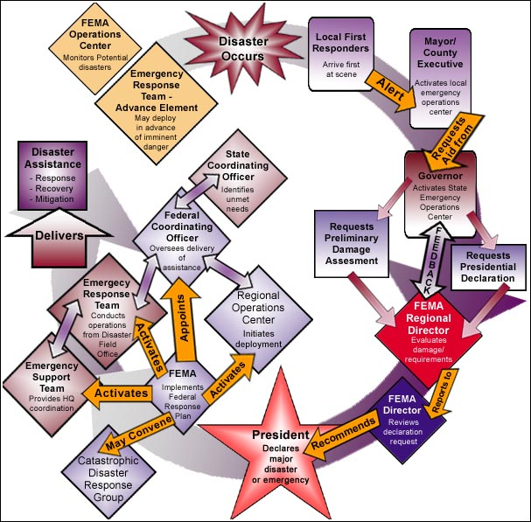
The federal government has established 28 US&R Task Forces throughout the nation able to deploy within six hours of notification. The map below shows the location of the 28 national US&R Task Forces.
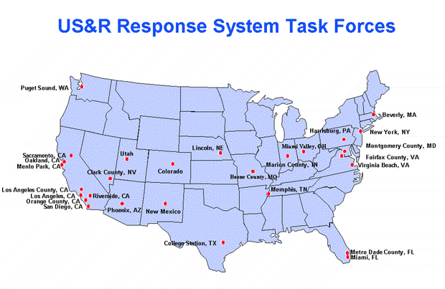

California has eight US&R Task Forces sponsored by the following communities:

Community | Official Designation
City of Los Angeles | CATF-1
Los Angeles County | CATF-2
City of Menlo Park | CATF-3
City of Oakland | CATF-4
Orange County | CATF-5
City of Riverside | CATF-6
City of Sacramento | CATF-7
City of San Diego | CATF-8

When deployed to an incident, 70 US&R Task Force personnel respond. In order to deploy 70 member teams, each task force maintains a roster of trained personnel for a total of 210 members (3 each per position). Each position is duplicated within a deployed Task Force in order to operate two 12-hour shifts, 24 hours a day. FEMA has established a goal of equipping and training by September 30, 2003, all 28 National Task Forces to respond to incidents involving weapons of mass destruction.

The US&R Task Force is totally self-sufficient for the first 72 hours and has a full equipment cache to support its operation. The equipment cache for each of the Task Forces is estimated at $2.0 million. In addition, local, state or federal resources may provide transportation and logistical support.

The members of a US&R Task Force train year-round to be ready for a deployment. The training requirements involve a significant commitment of overtime funding and resources by the sponsoring agencies (local fire departments).
[70]
Task Force members consist primarily of firefighters and other disciplines and professions such as: medical, law enforcement, structural engineering, heavy equipment operators, construction professionals and canine search handlers.

The multi-disciplinary organization of a US&R Task Force includes seven functional elements as follows:

- COMMAND COMPONENT – Two Task Force Leaders, assisted by
two Safety Officers, command the Task Force;

- SEARCH COMPONENT – comprised of two dog teams and a technical search team using listening and viewing equipment;
- RESCUE COMPONENT – consisting of four squads, each containing six members. Additionally, two heavy equipment-rigging specialists are attached to the rescue component and supply technical expertise. These squads have the capability to address any type of collapse and confined space rescue;

- HAZARDOUS MATERIALS COMPONENT– Consisting of ten Hazardous Materials Specialists;
- MEDICAL COMPONENT – Comprised of two teams, each with two paramedics and one physician;

- LOGISTICS COMPONENT – Consists of six Logistics Specialists and two Communications Specialists; and

- PLANNING COMPONENT – Consists of two Planning Specialists, two Structures Specialists, and two Technical Information Specialists.

Figure 3 illustrates the members of the US&R Task Force and the organizational structure.

Figure 3

STATE/NATIONAL US&R TASK FORCE

ORGANIZATION CHART

Resou

on l
… compromised due to local agencies may be affected..
[ Does anyone remember what we were looking for in this space???]

local resource federal
I “Heavy” Urban Search and Rescue and Type I Hazardous Materials response capabilities in each Operational Area. There is a demonstrable need to plan on supporting all Operational Areas with an appropriately planned response to catastrophe.

(SFM) has the authority tstanda
460 Inventory of Existing Resources

As of May 2003, the California OES Fire and Rescue Branch reported the following inventory of US&R resources within the Master Mutual Aid system

Figure 4 presents a summary of the current local US&R resources as currently recognized by OES.

The US&R resources within the Master Mutual Aid system are funded, staffed and maintained primarily by individual Fire Departments. Some of the Light Operational Level US&R resources are part of the California Office of Emergency Services (OES) Fire Engine replacement program. OES purchases and equips these fire engines with a Light Operational Level equipment inventory. Staffing and maintenance are the responsibility of the local Fire Department receiving these fire engines.

US&R resources must be evaluated and certified by OES as being compliant with minimum equipment, staffing and training requirements for the operational level being applied for to be included in the Master Mutual Aid System. Some Fire Departments having a US&R capability choose not to participate in the Master Mutual Aid System because they are reluctant to share the resources they have purchased with local funds and staffed on their own without any assistance from the State or other funding sources. Repairs or replacement to any damaged equipment while assisting in a mutual aid capacity is the sole responsibility of the Fire Department providing the US&R resource. Other Fire Departments having a US&R capability agree to participate in the Master Mutual Aid System but need financial assistance to obtain a few remaining more costly items and training to be compliant with OES requirements.

Due primarily to the homeland security efforts following the 9/11 terrorist attacks, the trend in California is to develop and secure more US&R and Hazardous Materials capabilities. Having these specialized resources spread throughout California and in higher concentrations in the more urban areas with larger populations provides the ability to rapidly respond to US&R and Hazardous Materials emergencies regardless of the cause of the emergency (natural or man-made).

US&R workers at NYC World Trade Center site.
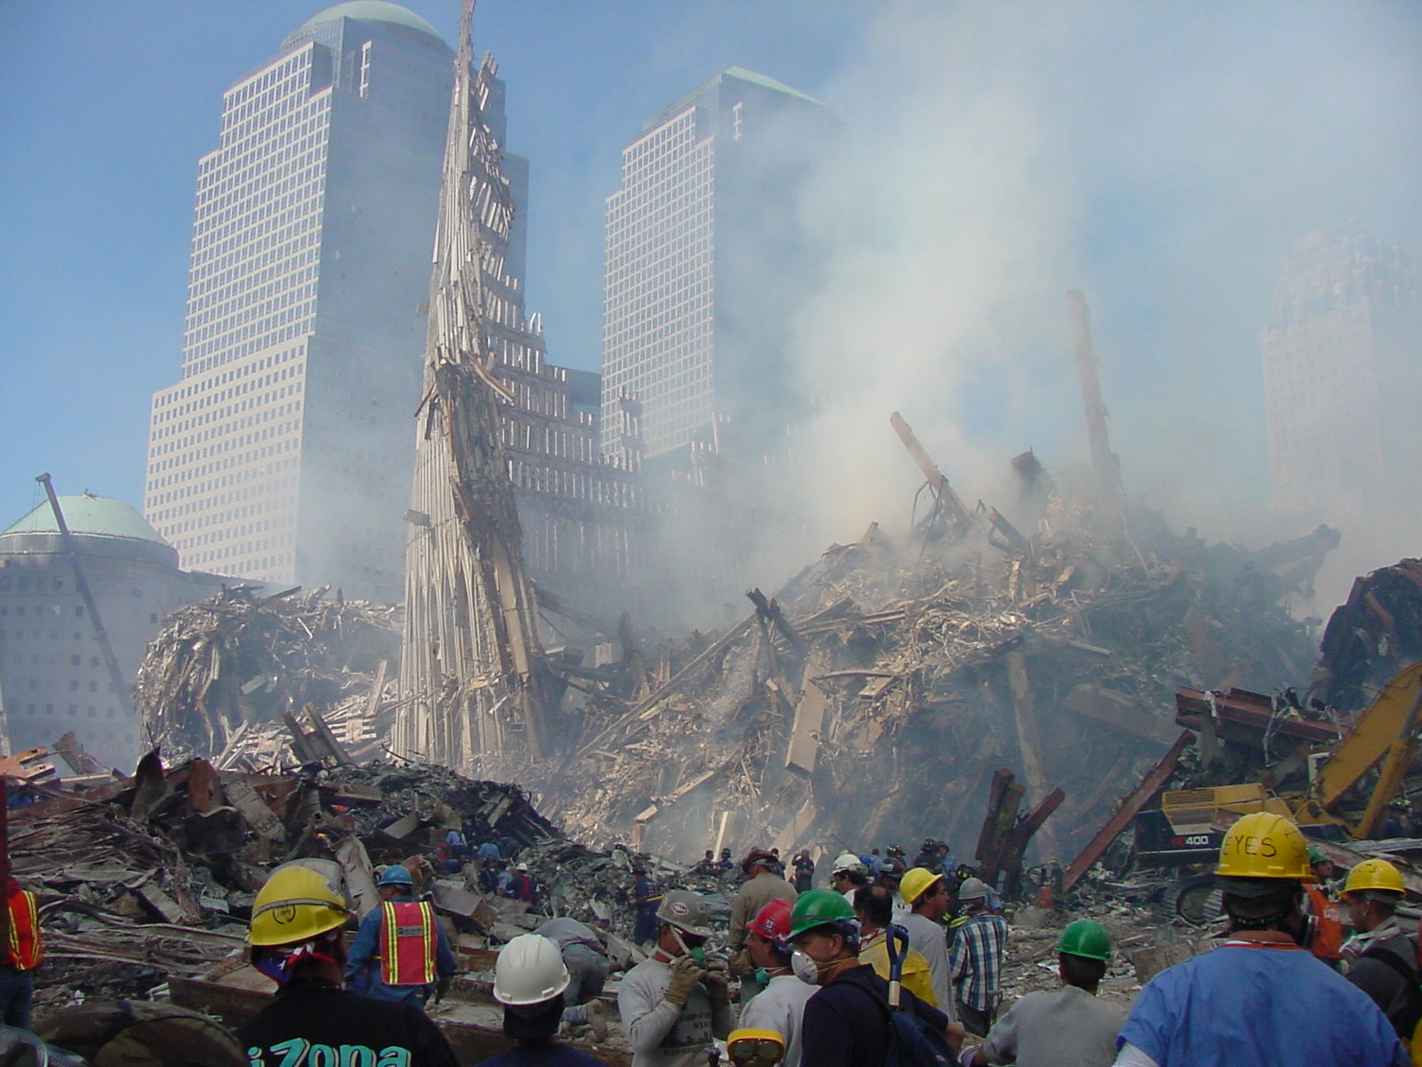
Figure 4
Existing Inventory of Local US&R Resources

Mutual Aid Region | Agency | ICS Type | Alpha – Company | Radio Designator | Date Typed
I | La Habra City Fire | 1 | Heavy |  | 11/03/1997
I | Long Beach Fire | 1 | Heavy |  | 05/23/2003
I | Montebello Fire | 1 | Heavy | US&R-560 | 05/16/2003
I | Orange City Fire | 1 | Heavy |  | 05/23/2003
I | Pasadena Fire | 1 | Heavy |  | 03/07/2002
I | Santa Fe Springs | 1 | Heavy |  | 11/03/1997
I | Ventura County Fire US&R-40 | 1 | Heavy | US&R-40 | 11/06/2002
I | Ventura County Fire US&R-54 | 1 | Heavy | US&R-54 | 11/21/2000
I | Vernon Fire | 1 | Heavy |  | 05/10/2002
II | Alameda County Fire | 1 | Heavy |  | 11/25/2002
II | Fremont City Fire | 1 | Heavy |  | 04/03/2000
II | Marin County Fire | 1 | Heavy |  | 04/15/1997
IV | Stockton | 1 | Heavy | Truck-3 | 05/27/2003
VI | Colton Fire | 1 | Heavy | Rescue-213 | 06/27/2003
VI | Rancho Cucamonga FPD | 1 | Heavy |  | 07/24/2000
VI | San Bernardino County | 1 | Heavy | Rescue-23 | 04/30/2003
VI | San Bernardino County | 1 | Heavy | Rescue-91 | 04/30/2003
I | Anaheim Fire | 2 | Medium |  | 01/04/2001
I | Beverly Hills Fire | 2 | Medium |  | 11/14/1997
I | Downey, City of | 2 | Medium |  | 11/03/1997
I | El Segundo, City of | 2 | Medium | US&R-31 | 05/02/2003
I | Montecito FPD | 2 | Medium |  | 03/27/2000
I | Santa Barbara City | 2 | Medium |  | 02/23/2000
I | Santa Barbara County | 2 | Medium | US&R-12 | 07/03/2000
I | Santa Maria City Fire SMR-231 | 2 | Medium | SMR-231 | 05/22/2000
II | American Canyon | 2 | Medium |  | 08/21/2001
II | San Rafael Fire | 2 | Medium |  | 05/28/2003
II | San Rafael Fire / PW | 2 | Medium |  | 05/28/2003
III | Chico Fire | 2 | Medium |  | 01/29/2002
IV | Modesto Fire | 2 | Medium | Rescue-85 | 10/16/2001
IV | Modesto Fire | 2 | Medium | Truck-71 | 10/16/2001
IV | Roseville Fire | 2 | Medium | Rescue-3 | 06/10/2003
IV | Sacramento Metro Fire | 2 | Medium |  | 04/10/1998
IV | Truckee FPD | 2 | Medium |  | 04/24/2002
V | Clovis Fire | 2 | Medium | Rescue-31 | 12/09/2002
VI | Carlsbad | 2 | Medium |  | 08/29/2001
VI | Montclair | 2 | Medium |  | 04/11/2001
VI | Ontario City Fire | 2 | Medium |  | 02/28/2000
VI | San Bernardino City | 2 | Medium | Rescue-230 | 04/30/2003
VI | San Bernardino County | 2 | Medium | Rescue-74 | 04/30/2003
II | San Ramon Valley Fire | 2 | Medium | US&R-34 | 06/12/2003
I | Santa Maria City Fire SMR-225 | 3 | Light | SMR-225 | 03/28/2000
I | Santa Maria City Fire SMR-227 | 3 | Light | SMR-227 | 03/28/2000
I | Santa Maria City Fire SMR-229 | 3 | Light | SMR-229 | 03/28/2000
IV | Modesto Fire | 3 | Light | Truck-75 | 09/25/2000
IV | Roseville Fire | 3 | Light | Truck-1 | 06/10/2003
IV | Stockton | 3 | Light | Truck-2 | 03/03/2003
IV | Stockton | 3 | Light | Truck-4 | 03/03/2003
V | Fresno City Fire | 3 | Light |  | 04/12/2001
VI | 29 Palms Fire | 3 | Light |  | 01/03/2001
VI | Center Fire - 29 Palms USMC | 3 | Light |  | 10/18/2002

Total Inventory of Local US&R Resources
US&R Type | Currently Officially Recognized by OES
Heavy | 16
Medium | 22
Light | 63

US&R rescue crews at WTC site in September 2001.

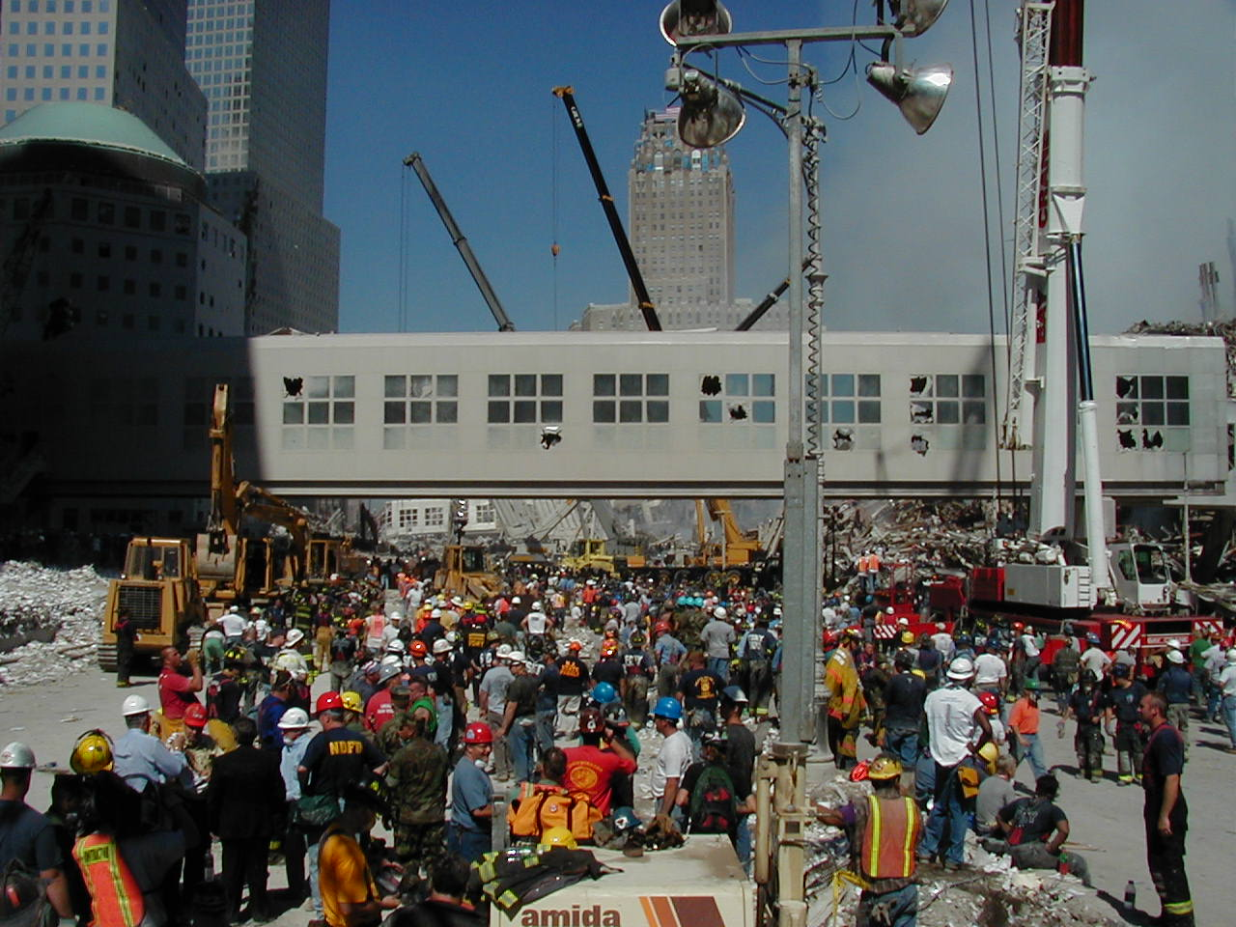

Assessment of Urgency

Incidents requiring US&R intervention can be caused by a range of events, such as an earthquake or terrorist incident that cause widespread damage to a variety of structures and entrap hundreds of people. Other examples of US&R events can range from mass transportation accidents with multiple victims to single site events such as a trench cave-in or confined space rescue involving only one or two victims. US&R operations are unique in that specialized training and equipment are required to mitigate the incident in the safest and most efficient manner possible.

Is the Current State US&R System Adequate? The California US&R Program, though diligently developed, is unable to address all current technical rescue needs without sufficient funding, especially given threats to public safety from recurring seismic activity, terrorism, and weapons of mass destruction

The eight State/National US&R Task Forces may not have the capacity to effectively handle the existing natural (earthquake, flood, fire) and non-natural (terrorism) threats to the State because most California cities lack the ability to adequately address the effects of a major earthquake, terrorism or weapons of mass destruction that strike within their own communities. Following the occurrence of a catastrophic earthquake or other significant emergency incident most municipal fire departments are not able to honor standing mutual assistance agreements upon which many jurisdictions rely for everyday fire protection.

Within the current system, there is a very limited resource base to draw upon when needed. Those teams that do respond bring varied levels of skill and expertise, determined largely by their ability to purchase specialized equipment and apparatus, and by the training and experience of the personnel.
First 24 Hours Critical History demonstrates that local responders rescue the majority of live victims within the first 24 hours following a significant event that caused multiple structures to collapse or fail. Structural collapse incident research indicates victim survivability drops below 30 percent if not rescued within the first 72 hours.

Delays to Rescue Services The California State/National US&R Task Forces and local US&R resources and Hazardous Material Response Teams could be immediately impacted by a catastrophic earthquake and unable to assemble or respond until hours or even days after the event.

Local resources responding to a wide-scale earthquake or other disasters will quickly be overwhelmed which will necessitate the need for mutual aid. Enough specialized US&R personnel and equipment is not likely to be available with the status of our present US&R response system. Even if all eight of the FEMA national Task Force Teams in California were mobilized, they would not be operational for more than 24 hours --which is after the “window of survivability” begins to rapidly close in structural collapse situations. Locally available US&R equipment and literally thousands of trained personnel are required to handle such incidents.

Even were FEMA able to immediately dispatch all 28 State/National US&R Task Forces to such a large urban area earthquake, it would take in excess of 24 hours to get all the Task Forces in place and operational.

Growing Threat Posed by Hazardous Materials. California US&R Task Forces and US&R trained personnel have responded to the Oklahoma City bombing, Pentagon and New York City World Trade Center (WTC) disasters in addition to several other emergencies both inside and outside California. While at these incidents, significant hazardous material concerns and events during US&R operations have caused FEMA to increase the number of Hazardous Material Specialists assigned to each State/National US&R Task Force. In addition to the increase in trained staff, the amount and type of hazardous materials response team equipment required in the US&R Task Force cache has also been significantly expanded.

Potential for Colossal Damage and Loss of Life in California As devastating as the disasters of Oklahoma City, Pentagon and at the WTC were, they would pale in comparison to the devastation caused by an earthquake of magnitude 8.0 in the Los Angeles Basin, or other large urban centers. The current inventory of local US&R resources and Hazardous Material Response Teams would be unable to effectively respond to the hundreds of emergency requests. To be their most effective, the State/National US&R Task Forces will need to be assigned to the larger, more complicated and severely damaged buildings and structures entrapping the most victims.

To address these vulnerabilities of the State US&R system, Local US&R Resources Need to Be Improved to Handle Potential Disasters To manage the magnitude of such disasters, the quantity and capabilities of local emergency response resources must be improved to effectively accomplish the time-sensitive requirements of saving lives, preventing property loss and reducing damage after such an event. To maintain an effective and credible response to such disasters, the existing local US&R capabilities, US&R Type I “Heavy” Teams, Type I Hazardous Materials Response Teams, regional Task Forces and the eight California State/National US&R Task Forces must be enhanced.

In enacting Chapter 460 (Statutes of 2002), the Governor and Legislature recognized that within the framework of the existing Mutual Aid network and the eight State/National US&R Task Forces in California, there is a need for an increased local urban search and rescue and hazardous material response team capability in the State system. Establishing and maintaining US&R “Medium” and “Heavy” Teams and Hazardous Material Response Teams imposes significant financial impact on local jurisdictions and need additional State and regional support.

Training Facilities Needed There is also a need to provide appropriate technical rescue and hazardous materials training facilities statewide. Currently, seven facilities (certified by California State Fire Marshal and the Governor’s Office of Emergency Services) that offer the required training curriculum:
- San Diego County
- Anaheim (North Net Training Center)
- Menlo Park
- Sacramento (McClellan Park)
- San Bernardino (Sewell Training Center)
- Modesto
- Los Angeles County (Del Val Training Center)

Additional facilities need to be constructed and existing facilities improved because the ability to deliver effective training to first responders is the single most important aspect of disaster preparedness in the modality of US&R. While proper equipment is indispensable to effective to US&R operations, without proper training, the availability of equipment in the hands of untrained and unqualified personnel is a tragically wasted resource.

The California OES has the capability to effectively distribute the appropriate equipment and training.

What are the Benefits of Expanding Local US&R Resources?
- Financial support for local response will enhance existing capabilities and establish additional US&R Type I “Heavy” and Type I Hazardous Materials response resources in each Operational Area. There is a demonstrable need to plan on supporting all Operational Areas with an appropriately planned response to a catastrophic event.
- Increase chances for faster first response within the first 24 hours, resulting in fewer fatalities.
- More efficient and expedited delivery of rescue services.
- Reduce risk of response time due to loss of locally impacted first responders.
- California would be taking an effective proactive role in preparing for future catastrophic events.

Current Needs and Rationale

The Urban Search and Rescue Emergency Advisory Committee reviewed the existing level of local US&R resources and the need for additional resources given the current known threats to public safety posed by earthquakes, and other disasters. Based on the Committee’s comprehensive review, the Committee noted the following areas of critical need:

US&R Type I (Heavy) Vehicles $43.5 million

An increased level of local US&R response capability could be achieved through the strategic placement of Type 1 (Heavy) US&R Companies throughout the state. Fifty-eight separate caches of “Heavy” US&R equipment as identified in Firescope ICS-US&R 120-1 and 58 associated transport vehicles are proposed. A Heavy equipment cache, combined with a transport vehicle and six specially trained firefighters comprise a Type 1 US&R Company. The combined cost of one equipment cache and one transport vehicle is estimated at $750,000.

This allocation of equipment and vehicles is determined by allocating one unit package (equipment and vehicle) for each of the State’s 58 counties. Recipients of the equipment caches and transport vehicles shall be required to participate in the California Master Mutual Aid system and provide staffing as required for Type 1 US&R Companies.

Communications $3 million

Many wireless communications systems currently in use by emergency services agencies throughout the state are incompatible with one another. Consequently, computerized frequency linking equipment is needed to enable dissimilar communications systems to interface. An allocation of $500,000 each for the six OES operational areas is proposed.

Type I Hazardous Materials Response Vehicles $43.5 million

An increased level of local hazardous materials response capability could be achieved through the strategic placement of properly equipped emergency response hazardous materials vehicles throughout the state. This would provide significant assistance to local jurisdictions in the event of a large-scale earthquake involving release of hazardous or toxic substances. These resources could also respond to weapons of mass destruction (WMD) terrorism incidents. Fifty-eight units (one for each county) at a cost of $750,000 each are proposed.

Recipients of the units would be required to participate in the California Master Mutual Aid System and provide appropriate staffing.

Training Facilities $80 million

Advanced specialized training for US&R and hazardous materials first responders must be available statewide if enhanced response capability is to be realized. It is proposed that six new, and three retrofitted, all-risk training facilities be built. A minimum of one training facility would be located in each of the six OES operational areas. The cost of each new facility is estimated at $10 million, and $6.67 million for each of the existing facilities that need retrofitting. These estimates exclude operating and maintenance costs associated with these facilities.

The training (equipment), structures, and buildings would facilitate training in – but not limited to - the following subjects: structural collapse, confined space rescue, trench rescue, mass transportation rescue, rope rescue, hazardous materials, WMD, live-fire training, heavy equipment operation, communications, mobilization and mutual aid exercises. Specialized tools, equipment, and vehicles would be needed at each facility as well as storage buildings, classrooms, and dining facilities.

Training Facility and Mobile Training Unit Equipment Cache $22 million

Nine equipment caches will be needed for the training facilities outlined above to train and familiarize first responders and US&R Task Force members with the tools and equipment in a standard Task Force cache. Two additional caches are proposed for mobile training units to be deployed as needed to areas around the state that may not be near a training facility. The cost of each equipment cache is estimated at $2.0 million each.
to insert in immediately preceding paragraph
State/National rce Back-Up ipmche $16 million

Each of the eight California State/National US&R Task Forces are required to provide three-deep staffing in each position. When a Task Force is deployed, the equipment cache is taken with them. If additional equipment were available, each Task Force has sufficient non-deployed personnel trained to respond to a local emergency. Providing a back-up equipment cache for each of California’s eight Task Forces would effectively provide the state with sixteen fully operational Task Forces. The cost of each back-up cache is estimated at $2.0 million each.

Local US&R and Hazardous Materials Response Team Equipment $20 million

Local US&R and Hazardous Materials Response Teams struggle to purchase required equipment through normal internal funding sources. Funds are required to provide or supplement US&R “Light”, “Medium” and “Heavy” equipment caches (as identified in (Firescope ICS – US&R 120-1) and Type I, II or III Hazardous Material Response Team equipment. Fully equipped and trained teams would be able participate in the Master Mutual Aid system thus increasing the capabilities and flexibility of the system.

Training $27 million

The US&R committee recommends including dedicated funding for training because, to be effective, first responders must be well-trained in the highly specialized realm of US&R (see Appendix for detailed calculations of training costs).

Figure 5 summarizes the identified elements and related costs to enhance the capability and readiness of local US&R services in California.

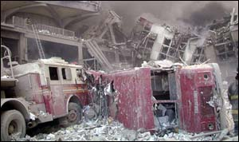
Damaged emergency vehicles at WTC disaster site.
Figure 5

ACQUISITION OF VEHICLES AND EQUIPMENT FOR

URBAN SEARCH AND RESCUE SERVICES IN CALIFORNIA

Item | Unit Cost Detail | Estimated Amount  ($ millions)

I. US&R Type I Vehicles
US&R Type I “Heavy” Vehicle + Equipment | $ 750,000 / unit | $43.5
II. Communications
For event-site universal  radio communications  capability (1 ea./ OES region) | (6 OES regions) | 3.0

III. Type I Hazardous Materials Vehicles
Hazardous Materials Vehicle + Equipment | $ 750,000 / unit | 43.5
IV. Training Facilities
1 per each OES Region  (“all-risk” training capability) | 6 facilities (new construct.)  3 existing facilities (rehab) | 60.0  20.0
V. Training Facility and Mobile Training Unit Equipment Cache | 9 units for 9 training facilities;  2 units for 2 mobile training units | 22.0
VI. State/National US&R Task Force Back-up Equipment cache | ($2 million / cache)  8 units for back-up | 16.0
VII. Local US&R and Haz Mat Team Equipment |  | 20.0
VIII. Training | US&R Type I and Haz Mat Type I for 58 Counties  (Three persons deep in each required position) | 27.0
Total (rounded) |  | $ 255.0

Future Influences

The need to enhance US&R capabilities through the State of California may vary over time. There are a series of influencing factors that in the future will change the level and urgency of the need to add greater urban search and rescue, and hazardous materials response capability in the form of equipment, facilities, and training for first responders and the community.

Economic Factors. Economic influences with respect to the State of California’s budget and its ability to fund future urban search and rescue or hazardous materials resources or programs will affect the need and urgency for enhanced response resources. Increases in costs associated with equipment, salaries for personnel, construction costs are among the more volatile economic or financial influences.

Local Government Participation. The willingness of county and local government to participate in a statewide program providing these additional resources is also an influence that could have significant affect on the success of providing adequate urban search and rescue and hazardous materials capability throughout the state. The size, composition, and organization of local responder agencies and fiscal resources are factors that may influence a jurisdiction’s decision to participate in this program.

Catastrophic Events. Occurrences of catastrophic earthquakes, floods, significant hazardous chemical releases, mass transportation, terrorist/WMD and other similar disasters could affect or redefine local government participation. The willingness or desire on the part of county and/or local government to participate in a statewide program that provides adequate urban search and rescue and hazardous materials emergency response capabilities ensures faster and less costly recovery efforts within those communities. Historically, such catastrophic events trigger elected officials at all levels to take actions to address these needs.

Other Legislation. Other legislation adopted at the State or federal level could also influence the need for additional resources, such as creating a federal mandate for States to provide specific capabilities, or as has been the case with the FEMA funding support for the US&R Task Forces at a modest level. Other examples include changes in codes and ordinances, or national standards that alter communities risk for damage from various types of disasters.

Technological enhancements. Technological advancements in search, rescue, and hazardous materials detection and mitigation equipment may influence the direction or need for additional equipment or resources. Technological improvements in building materials, construction techniques, and related areas may also alter the need for these specialized resources.

Findings

- Given that victim survivability in collapsed structures dramatically decreases after the first 12 to 24 hours, and that California’s eight US&R Task Forces generally take 24 hours or more to become fully operational, it is imperative that trained and equipped local US&R First-Responders are available for emergency response throughout the state.

- The ability of emergency response agencies, particularly those operating under mutual-aid agreements, to respond expeditiously and effectively during disaster situations is critical to saving lives and preserving property. However, various factors, including local vulnerability (direct injuries and damage to local personnel and facilities) and development delays could compromise the responders’ abilities to deliver prompt and effective services.

- Local governments alone cannot shoulder the financial burden of developing and maintaining the personnel, equipment and training needs of local US&R resource teams.

- The benefits of well-maintained and equipped local US&R resource teams extend to regional and State jurisdictions.

- The emergency response equipment being utilized by many local agencies is aging, and less effective than newer equipment being developed and made available to local emergency response agencies. Standardized apparatus with adequate space for the volume of new equipment is often a factor that limits its capability.

- Emerging technological advances are continuing to develop emergency response equipment that is effective and efficient, yet costly to local government agencies. Among these new items: technical search cameras, specialized personal protective equipment, and monitors to detect the presence of nuclear, biological and chemical agents.

Recommendations

The US&R Advisory Committee’s recommendations are as follows:

- Actively support the improvement and expansion of local US&R teams;

- Immediately and aggressively pursue funding from federal, state and other public or private sources to finance the acquisition of vehicles and equipment, the construction and improvement of training facilities, and the expansion of specialized training, in accordance with the schedule set forth in the table presented as Figure 5 of this Report;

- Direct the Office of Emergency Services, in consultation with the California Seismic Safety Commission and the State Fire Marshal, to develop a detailed, multi-year master plan and timeline for the acquisition of the vehicles and equipment, the construction and rehabilitation of facilities and the expansion of specialized training for the improvement of local US&R resources; and

- Establish an Oversight Committee to supervise the State’s efforts to carry out these recommendations in a timely, cost-effective and expedited manner.

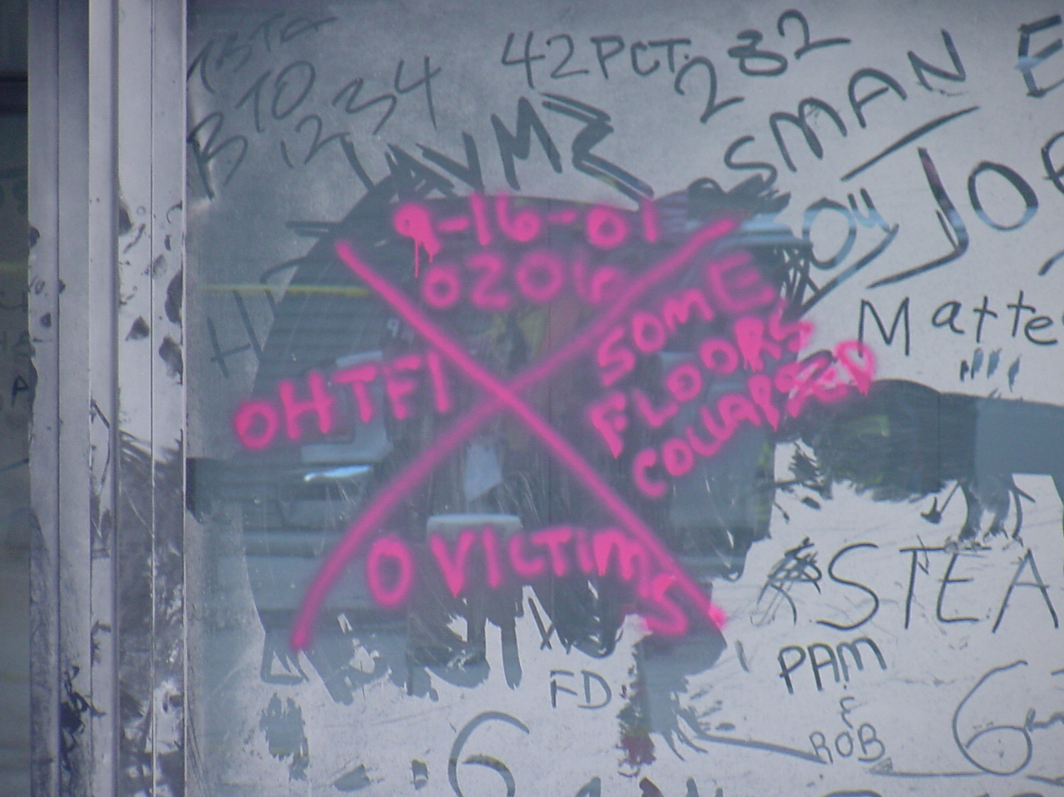
Technical US&R markings on building describing conditions and status of structure.

APPENDIX

Urban Search and Rescue Emergency Advisory Committee

SEISMIC SAFETY COMMISSION | Douglas Mochizuki  Committee Chairman and Commissioner
Donald Parker
Commissioner
Donald O. Manning
Commissioner
Richard McCarthy
Executive Director
Henry Sepulveda
Project Director / Legislative Director
Abigail Browning
Legislative Assistant
GOVENOR’S OFFICE OF EMERGENCY SERVICES | Mike McGroarty  Deputy Chief
CALIFORNIA DEPARTMENT OF FORESTRY & FIRE PROTECTION | Lloyd Limprecht  Deputy Chief  Kevin Lockwood  Division Chief
STATE FIRE MARSHAL | John Tennant
LOS ANGELES CITY FIRE DEPARTMENT | Dean Cathey  Chief
Tim Kerbrat
Captain
SAN BERNARDINO COUNTY FIRE DEPARTMENT | Peter Hills  Chief
Jim Pearson
Captain
SANTA MONICA  FIRE DEPARTMENT | Jim Hone  Fire Marshal
SACRAMENTO METRO FIRE DEPARTMENT | Jeffrey L. Metzinger  Battalion Chief
CALIFORNIA STATE  SHERIFFS ASSOCIATION | Lt. Robert Curry  San Diego County
Sheriff's Reserve John McKently
Los Angeles County
CITY OF RIVERSIDE FIRE DEPARTMENT | Dave Lesh  Battalion Chief

Presentations Made to the Committee

Jim Hone, Fire Marshal; City of Santa Monica Fire Department. “Lessons Learned from the Alfred P. Murrah Federal Building Bombing.” January 10, 2003.

Dean Cathey, Chief; City of Los Angeles Fire Department. “Lessons Learned from the Northridge Earthquake, 1994.” January 10, 2003.

Chris Kawai, Chief; City of Los Angeles Fire Department; Lessons Learned from Deployment at the World Trade Center Disaster, 2001.” January 10, 2003.

Donald R. Parker, Chief; City of Vallejo Fire Department; “Lessons Learned from the Loma Prieta Earthquake, 1989.” March 4, 2003.

John McKently, R/Commander; Los Angeles County Sheriff’s Department and Robert Curry, Lieutenant, San Diego County Sheriff’s Department; “Integrating Wilderness Search and Rescue Teams into Disaster/Urban Response.” March 4, 2003.

Jim Pearson, Captain; San Bernardino County Fire Department. “Training Center Elements for Realistic and Effective US&R Training.” March 4, 2003.

Dean Cathey, Chief; City of Los Angeles Fire Department. “Update of US&R Task Force Meetings in Washington, DC in March 2003.” May 1, 2003.

Glossary

Cache A specific collection of specialized tools and equipment corresponding to a US&R operational capability used to perform US&R operations.
Commission California Seismic Safety Commission

Committee Urban Search and Rescue Emergency Advisory Committee, created under Chapter 460, Statutes of 2002 (AB 2002, Alquist) to advise the Commission.

FEMA Federal Emergency Management Agency

OES Governor’s Office of Emergency Services

Operational Area A delineation of geographical areas as described in the California Master Mutual Aid Agreement. Each county within the State is considered an operational area and is geographically located in one of six Mutual Aid regions.
SSC California Seismic Safety Commission

Technical Rescue (also known as Urban Search and Rescue, or US&R) The application of special knowledge, skills, and equipment to safely resolve unique or complex rescue situations (examples: confined space rescue, trench rescue, swift water rescue, low-to-high angle rope rescue, structural collapse, mass transportation accident rescue, industrial accident entrapment rescue.

US&R Urban Search and Rescue

Calculations of Training Costs

US&R TRAINING

Category Training Module Hours Req’d

US&R Type 3 (Light) Rescue Systems 1 40
US&R Type 2 (Medium) Rescue System 2 40
Trench Rescue 24
Confined Space Rescue 40

US&R Type 1 (Heavy) Technical Rope Rescue 40
Rescue Systems 3 40
80

Total Hours for US&R Training 224 hrs.

HAZARDOUS MATERIALS TRAINING

Haz Mat Technician Haz Mat 1A 40 Haz Mat 1B 40
Haz Mat 1C 40
Haz Mat 1D 40

Haz Mat Specialist Haz Mat 1E 40 Haz Mat 1F 40

Haz Mat WMD Haz Mat WMD 24

Total Hours for Haz Mat Training 264 hrs.
US&R AND HAZ MAT TRAINING COST ESTIMATES

US&R Course Costs:
- 6 US&R Courses
- @ 224 hours
- $1,650 per student

Student overtime back-fill costs:
- $25.00/hour
- @ 1.5 rate = $37.50/hour
- @ 224 hrs.
- $8,400 overtime back-fill cost per student

Total cost per student: $10,050

US&R Type 1 (HEAVY) Company
- 6 personnel in the Company
- 3 personnel deep
Total cost: $180,900

Total US&R Training cost for 58 counties $10,492,200

Hazardous Materials Course Costs:
- 7 Haz Mat Courses
- @ 264 hrs.
- $3,600 per student

Student overtime back-fill costs:
- $25/hr
- @ 1.5 rate = $37.50/hr.
- @ 264 hrs.

Total overtime cost per student $9,900

Total cost per student $13,500

Haz Mat Type 1 (WMD) Company
- 7 personnel in the Company
- 3 persons deep
- @ $13,500 per student
Total Cost $283,500
Total Cost for 58 Counties $16,443,000

Grand Total for US&R and Haz Mat Training (all counties) $26,935,200

The California Earthquake Loss Reduction Plan, a five-year strategic plan, is published by the California Seismic Safety Commission, as mandated by Government Code Section 8870, et seq.
“No-permit-required-for-confined-space-entry refers to Cal OSHA regulations governing work (including rescue) in confined spaces.
Permit–required confined space entry refers to Cal OSHA regulations governing work (including rescue) in confined spaces and is more stringent than “no-permit-required” confined space entry.
Some less densely populated counties may not opt for a US&R Type 1Company. Some more populous (larger urban) counties may require more than one unit.
Presumably, some less densely populated counties may not opt for an emergency response hazardous materials vehicle; some more densely populated counties may require more than one. The units would require local staffing by hazardous materials technicians and be equipped with a standardized emergency response equipment inventory. The units would be also equipped for mass-decontamination capability.
FEMA has a proposed budget to supply each of the 28 State/National US&R Task Forces with a back-up equipment cache.

