California Seismic Safety Commission’s Year Five and Six Report to the Legislature on the Pacific Earthquake Engineering Research Center

August 2003

The Pacific Earthquake Engineering Research (PEER) Center is an engineering research center established by the National Science Foundation and the State of California. The mission of the Center is to “develop and disseminate performance-based earthquake engineering (PBEE) methodology and supporting technologies to meet the safety, functionality, and economic needs of owners and society.” PBEE is the current widely accepted state-of-the-art methodology for the seismic design of buildings and other structures, in which owners and other decision makers define performance targets in terms of safety, cost, and functionality needs.

Existing law requires the California Seismic Safety Commission (Commission) to periodically monitor the work of the PEER Center on the state’s behalf, produce an independent evaluation, and recommend priorities for the PEER Center to contribute to the reduction of earthquake losses. This report is prepared and presented in accordance with Government Code Section §8876.1 and Contract No. SA3912, between the Regents of the University of California, Berkeley (the host of the PEER Center), and the Commission and covers October 2001 through July 2003.

Accordingly this report provides the following:

- A detailed description of the PEER Center (See the Appendix beginning on page 7).

- Interpretation of the results of the PEER Center’s research to indicate how they may affect State law and policy (See Appendix, pages 17 through 19).

- Recommendations for ways to better promote the application of research.

Recommendations for updated priorities that would contribute to achieving the Center’s objectives, provide direct benefits to California residents and businesses, and lead to the completion of specific recommendations in the State’s earthquake risk reduction program.

The Commission’s recommendations are:

- Maintain and, if possible, increase State support and involvement, including obtaining more input from the Commission regarding major research priorities.

- The PEER Center should increase efforts to develop business, industry, and government partners. These include the various practitioner institutes and organizations that are or should be affected by the PEER Center’s work.

3. The PEER Center should further develop its information dissemination and outreach efforts to the public and to interested stakeholders including those in business, industry, and the government. These efforts should include more regular announcements of important upcoming PEER Center and related topical events and activities via e-mail and by maintaining permanent stakeholder e-mail address listings as appropriate.

Successes of the Center:

The PEER Center has been successful in the following activities:

- Since 1997, the PEER Center has brought over $18 million to the state in federal and private industry grants.
- Developed new liquefaction hazard curves.
- Improved standards for the seismic qualification of electrical equipment for substations.
- Involved electric utilities serving high seismic areas, who are helping to guide the development of applied research for electric components intended to increase resistance to earthquake damage of transmission and distribution systems
- Included PEER Center research results into guidelines for seismic slope stability analysis.
- Presented PEER Center’s research activity results at professional meetings to practitioners.
- Maintained alignment with the California Earthquake Loss Reduction Plan initiatives.
- Further developed the OpenSees computerized structural modeling and simulation of complex structural systems.

One of the most successful endeavors of the PEER Center is the way that it’s research results are affecting state law and policies by obtaining high quality seismic performance information on structures and buildings and related seismic hazard information after earthquakes in a manner that is useful in the development of regulations.

The PEER Center's results are already causing significant improvements in the way structures are evaluated and designed in California. The PEER Center has been able to identify how certain design methods can lead to collapse in structures shaken by severe earthquakes. This work helped create better ways to design new concrete buildings that will be contained in California's 2006 Building Code. Similarly, the PEER Center's work on electrical equipment has helped lower costs and improve the reliability of qualifying them as earthquake resistant.

Opportunities for the Center:

The number of universities interacting with the PEER Center on specific projects is likely to grow with the startup of the Network for Earthquake Engineering Simulation (NEES). The PEER Center is a member of NEES, as are the other NSF sponsored earthquake engineering research centers, the Consortium of Universities for Earthquake Engineering, the Southern California Earthquake Center, and other organizations working on earthquake related issues.

The PEER Center has established a name for itself by: in developing utility equipment fragility curves, serving as a reviewer of a proposed seismic retrofit program for a large mass transit district, and in its development of the Next Generation of Attenuation (Ground Motion) Curves. This activity has caught the attention of the California Earthquake Authority (CEA), which is looking for assistance in preparing for earthquake insurance rate hearings in 2004.

Calibration and validation of current and proposed earthquake related building code requirements by the PEER Center and other researchers have the potential to drive down the seismic risk management and design costs of new structures and retrofits of existing structures.

Challenges facing the PEER Center:

Some of the challenges facing the PEER Center include:

- Obtaining much needed funding from government and private industry during a time of economic difficulty;
- Maintaining existing levels of State support;
- Balancing the needs of the National Science Foundation with those of other major funding partners;
- Recruiting, retaining, and increasing subscribers, partners, or members of its Business and Industry Partners (BIP); and,
- Demonstrating to the public the value of the PEER Center research, products, and seismic hazard mitigation in general.

Additional funding requests for the PEER Center:

The Commission understands that the State’s budget is under duress. However, the Commission also recognizes that the PEER Center’s research capability currently operates at a fraction of its full potential because of limited funds. Specific areas where PEER can effectively direct its efforts and drive down earthquake risk should the opportunity present it are as follows:

Information Service for Earthquake Engineering – The University of California, Berkeley, has operated the National Information Service for Earthquake Engineering since 1971 with funding from the National Science Foundation. The service provides earthquake professionals with online and on-call access to technical data and procedures necessary for mitigating seismic risk. NSF funding reductions threaten the program. The Commission recommends that the State of California provide $70,000 annually to match the amount to be provided by federal sources, enabling this valuable program to continue to operate.

Improving Seismic Safety and Cost-Effectiveness of Essential Facilities –The seismic assessment of existing hazardous buildings are a principal area of study for the PEER Center. The PEER Center seeks additional funding to establish, in collaboration with practicing earthquake professionals, improved procedures for seismic retrofit of existing essential buildings including hospital facilities. The PEER Center also proposes to conduct studies to address tradeoffs between various retrofit timeframes and objectives. The Commission therefore supports the PEER Center’s request for this purpose of $2 million dollars per year for three years.

Improving Seismic Safety of Schools – Seismic safety of public schools remains a primary focus of seismic safety efforts in California. With modest additional funding the PEER Center could focus its performance-based engineering methodology and its considerable retrofitting technology testing capabilities to identify more cost-effective mitigation measures for existing buildings for use as school buildings and for existing school buildings built to outdated standards. The Commission supports the PEER Center’s request for additional funding of $230,000 per year for three years to carry out this effort.

Development of Consensus Document on Performance-Based Earthquake Engineering – The PEER Center proposes to collaborate with the Applied Technology Council (ATC) to develop consensus-based guidelines for performance-based design of new buildings. Federal funding is expected to be available to support the consensus process, but additional technical studies are needed to maximize the cost effectiveness of the proposed guidelines. The PEER Center and ATC will identify areas of greatest need. The Commission therefore supports the PEER Center’s request for funding of $700,000 per year for five years.

Summary Table for Additional Requested Funding | Amount Requested
Information Service | $70,000/year
Essential Facilities | $2,000,000/year for three years
Seismic Safety of Schools | $230,000/year for three years
PBEE Document Development | $700,000/year for five years
Total Additional Funding Requested over Five years | $10,540,000
Table No. 1: Requested additional peer center funding

What are future threats to the PEER Center?

The most significant threat to the future of the Center is the uncertain funding base by the state and federal government and private (other) sources. One potential solution to this instability would be the recruitment of additional state, and private partners to fund directed projects of particular interest to the PEER Center and the funding partners.

The Justifications for the Commission’s recommendations are:

- Since 1989 California has spent an average of over five billion dollars a year (in combined federal, state, and private funds on seismic hazard assessment, mitigation and risk management. On average, California experiences a significantly damaging earthquake every ten years. By supporting PEER efforts in developing applied seismic hazard assessment, mitigation and risk management tools, the State reduces its loss potential from large earthquakes.

Currently, some of the research conducted by the PEER Center’s researchers is unique in that it is not being duplicated by other research facilities. The PEER Center management and its funding partners have recognized the need to conduct research at levels that allow solving challenges such as:

- Deformation assessment of soils supporting buildings and structures;
- The performance characteristics of critical electrical equipment and bridge components;
- The development of electrical and highway system analysis tools;
- The development of near real time monitoring of remote structures and systems during earthquakes; and,
- Analysis procedures consistent with accuracy necessary for practical performance based design.

- In order to derive its work’s full benefit to society, the PEER Center needs more timely communication and input from practitioners in the fields of civil and structural engineering, geotechnical engineering, engineering seismology, engineering geology, emergency response management, policy development, sociology, insurance, risk management and other fields. The input will allow for the PEER Center’s resources to be aimed at the development of practical tools for use in PBEE applications.

The Commission suggests that the PEER Center can make a significant difference in the calibration and validation of earthquake design codes throughout the State of California. Calibration and validation would determine if:

- Current and proposed earthquake engineering code assumptions are reasonable and reliably meet or exceed performance objectives; and,
- Code requirements can be modified to reduce costs while maintaining or improving life safety and reducing property damage.

Presently, the PEER Center is comparing new PBEE methods with current state-of-the-practice seismic rehabilitation techniques for the Van Nuys testbed building. A similar project is underway for bridge design methodologies assessment using a portion of the Interstate 880 Caltrans Viaduct in Oakland. These types of efforts could eventually lead to the transfer of PEER Center products to practitioners, while giving code developers a way of checking out the reasonableness or new and existing earthquake engineering codes.

Another of the PEER Center’s projects is the validation (checking) of selected ground motion models that are used to estimate the rate of decrease in ground motion away from an earthquake epicenter (called ground motion attenuation models). This project should help designers reduce the cost of design and construction by using more reliable and accurate information. Building and facility owners will also be able to measure the anticipated level of performance prior to and during earthquakes.

Report conclusions:

In summary, for this reporting period, the Commission hereby reports the following set of facts and conclusions:

- The PEER Center continues to be in alignment with the California Earthquake Loss Reduction Plan and California’s Research and Implementation Plan.
- Some 150 projects were completed or underway during the reporting period of October 2001 through July 2003. These projects cover at least nine of the eleven elements contained in the 2002-2006 edition of the California Earthquake Loss Reduction Plan.
- The PEER Center’s Lifelines and Core Programs are continuing to develop new scientific and engineering underpinnings needed to improve the specification of earthquake ground motions for engineering design.
- Under existing State law the PEER Center is apparently meeting most of its goals. Many of the reasons why all PEER goals have not been met stems from the lack of funding. The Commission therefore supports the PEER Center’s requests for additional funding.
- Work at the PEER Center is affecting State laws and policies in a manner that is useful in the development of appropriate regulations.
- Pursuant also to meeting its goals, the PEER Center needs to further improve its communication, information dissemination, and outreach efforts.

Appendix

Detailed description of the PEER Center and its activities

What is the PEER Center?

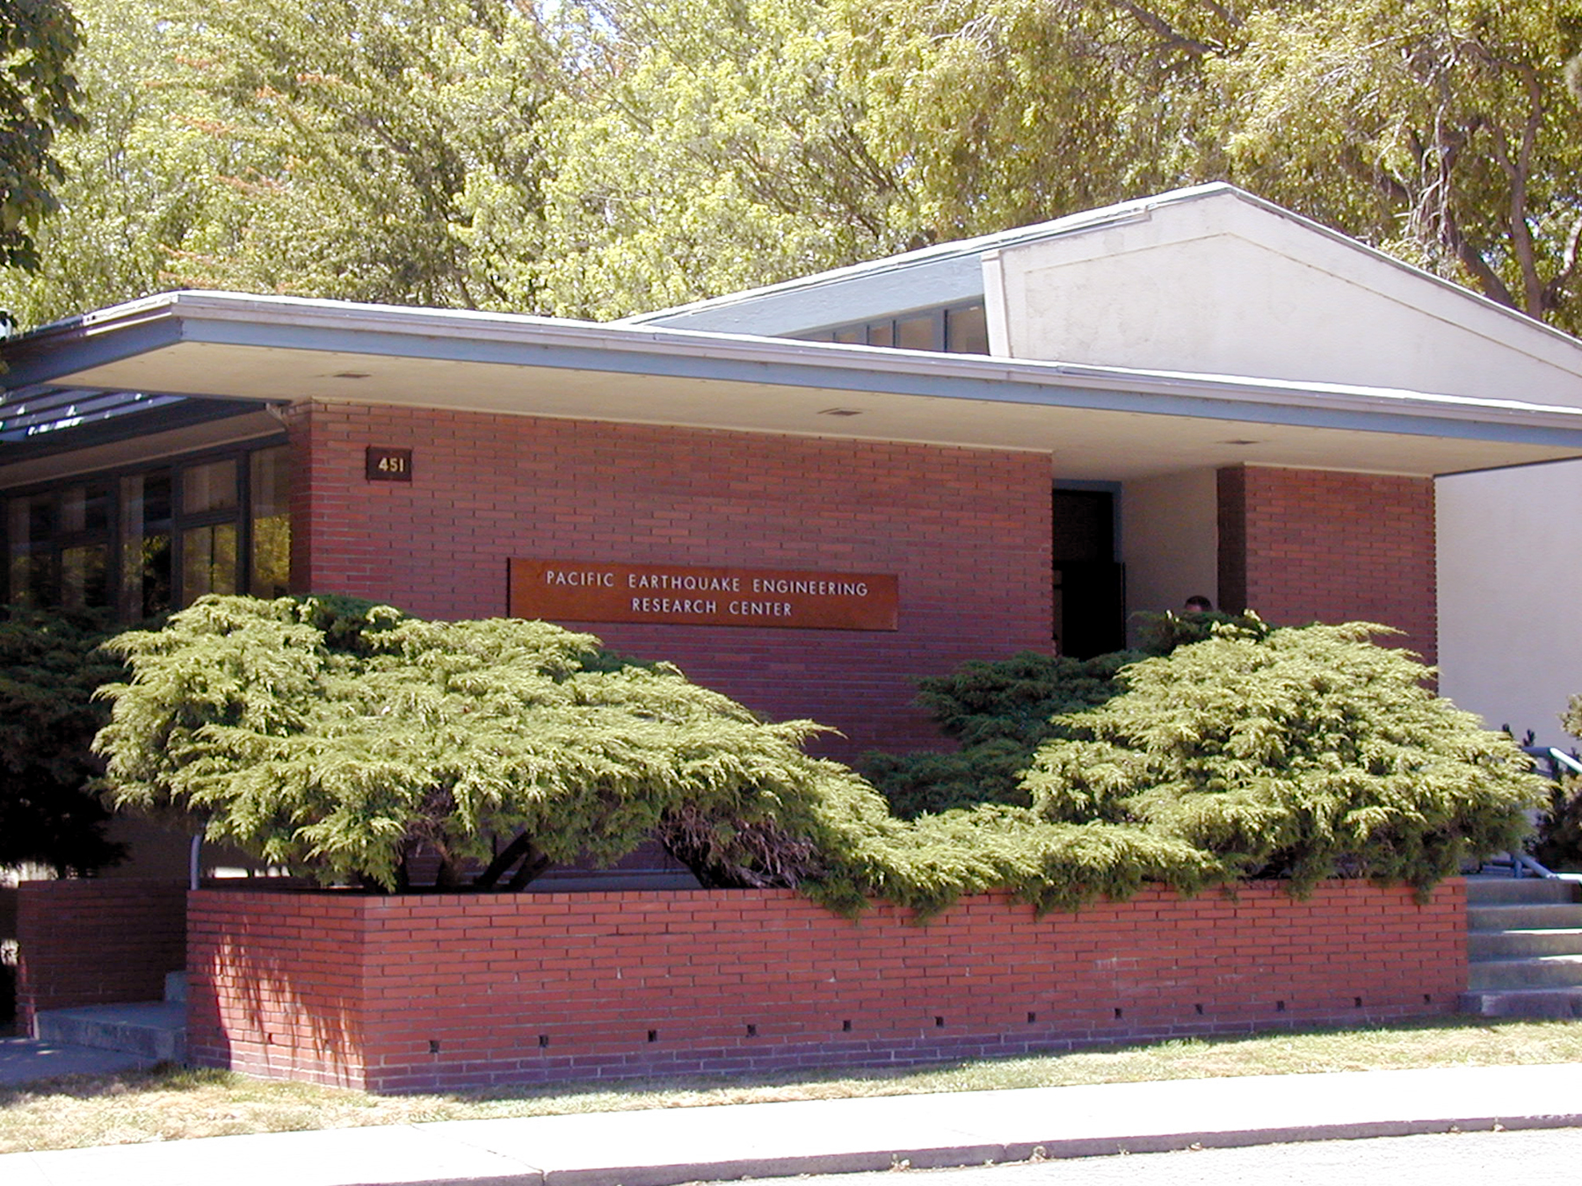
Figure 1: Entrance to the PEER Center

The PEER Center is a National Science Foundation (NSF) earthquake engineering research center located at the University of California, Berkeley campus, Richmond Field Station. The PEER Center is a part of NSF’s program to reduce losses due to earthquakes through the National Earthquake Hazard Reduction Program (NEHRP). The Federal Government, the State of California, and private industry provide funding for the Center. Investigators from over twenty universities and several consulting companies conduct research in earthquake-related geohazard assessment, engineering seismology, risk management, public policy, and geotechnical and structural engineering.

PEER organizes its research around the concept of performance-based earthquake engineering, in which owners and other decision makers define performance targets in terms of safety, cost, and functionality needs. This approach translates these performance targets into engineering criteria that aim to produce facilities that perform to expectations.

In addition to conducting research to develop performance-based earthquake engineering technology, the PEER Center’s mission is to disseminate its findings to earthquake professionals who ensure the results are useful, useable, and used.

PEER has nine Core Institutions and nine Affiliated Institutions in seven western states:

Core Institutions:

- California Institute of Technology
- Stanford University
- University of California, Berkeley
- University of California, Davis
- University of California, Irvine
- University of California, Los Angeles
- University of California, San Diego
- University of Southern California
- University of Washington
Affiliated Institutions:

- California Polytechnic University
- San Jose State University
- Universities of Alaska, Fairbanks
- University of Hawaii
- University of Utah
- University of Nevada, Las Vegas
- University of Nevada, Reno
- Oregon State University, and
- Washington State University

What are the Center’s goals?

The PEER Center’s goals include the development of a fully integrated approach for more reliable earthquake engineering to meet the needs of the public. These goals also include:

• Establishing liaisons with business and industry leading to continuous and mutually beneficial interactions;
• Fostering the transfer of knowledge and technology into design and construction practice;
• Developing next-generation earthquake engineering technology to meet the needs of the construction industry;
- Providing university students with a broad understanding of the requirements for bringing sophisticated products from the laboratory to the marketplace;
- Pursuing crosscutting interdisciplinary research and education; and,
• Improving training for practicing engineers.

During this Year Five and Six reporting period of October 2001 through July 2003, there were 150 research projects being carried out by PEER researchers. Thereafter the Center is scheduled to begin Year Seven of its overall ten-year research program.

What are the Center’s Benefits to California?

California has the greatest seismic risk exposure of any state in the country. The annual projected losses to the building stock alone are estimated by FEMA at approximately $3.3 billion in California, or approximately 75% of all the known annualized seismic risk of the entire country. This is due to the combination of geology and that most of the population and associated businesses and industry are concentrated in areas of high seismicity.

The PEER Center’s research and technology transfer activities benefit the State by helping to systematically reduce seismic risk through the development of performance-based earthquake engineering technologies and products, the transfer of the results of the Center’s research to the public and private sectors, and in the training of future students, engineers, and researchers. As of July 2003, three of the major PEER Center activities that have made a significant impact are:

- Electric utility equipment testing, electric utility building resistance to ground shaking;
- The production of new liquefaction potential curves for use in siting of buildings and structures; and,
- PEER Center research results that were incorporated in the Recommended Procedures for Implementation of Division of Mines and Geology Special Publication 117: Guidelines for Analyzing and Mitigating Landslide Hazards in California.

All three activities have come from the Lifelines Program of the PEER Center. Products from the Core Program of the PEER Center are longer duration in scope and may involve a broader audience.

During the lifetime of the PEER Center the average annual level of seismic hazard mitigation statewide exceeded $5 billion. Even with such a large expenditure of monies into seismic hazard mitigation much still remains to be done. The PEER Center’s world-renowned research has already had a positive impact on the utilities and transportation fields. In order to help make that seismic hazard mitigation more cost effective, the PEER Center has undertaken a user driven research approach, where researchers, funding entities and those who implement seismic hazard mitigation work together to develop credible and useful contributions to increasing seismic safety throughout the state and in some cases the world.

Another PEER Center product being developed will allow engineers, planners, and emergency response officials to better assess the state of bridges and buildings after earthquakes and aftershocks.

One project in particular has brought together many different research groups from Japan and the United States to work on lateral spreading and seismic shaking problems, for pipelines, bridge and wharf piers, and wharves. This is especially critical for California ports, harbors, and marine oil terminals.

It is expected that the PEER Center’s current major efforts in earthquake damage assessment for bridges, buildings, and electrical equipment as well as new ground motion intensity assessment tools will be completed by September 2006. As a result, advanced planning for new projects is underway at the PEER Center. The general direction of the new projects is anticipated to take advantage of the establishment of the Network for Earthquake Engineering Simulation (NEES), more active interaction between the PEER Center, the Multi-Disciplinary Center for Earthquake Engineering Research at the State University of New York (MCEER), and the Mid America Earthquake (MAE) Center, Southern California Earthquake Center (SCEC), Consortium of Universities for Research in Earthquake Engineering (CUREE), the National Center for Research in Earthquake Engineering in Taiwan, various Japanese and European earthquake engineering groups, and guidance and support from the State of California as well as the Federal Government. This approach takes advantage of the opportunities available at other research organizations and highlights the fact that the PEER Center is not intended to be the sole earthquake engineering research center but is a vital contributing member in a family of organizations serving California and the world. This will allow the PEER Center to contribute to and benefit from research at many other centers.

The PEER Center is specifically working with other earthquake engineering research centers in the United States and in Europe, Japan, and Taiwan, already have lead to the sharing of information regarding specific performance based earthquake engineering research results for bridge components and highway transportation system studies that can help emergency response officials direct traffic around major traffic blockages.

Project area’s that highlight the potential for collaboration include the sharing of information on the assessment of a life sciences laboratory building on a University of California campus (a PEER Center project) and hospital seismic safety retrofit research being carried out at the MCEER.

PEER has two heavily interrelated major components: the Core Program and the Lifelines Program. Under the Core Program, the PEER Center is developing performance-based earthquake engineering technologies that address the economic and safety needs of property owners and society. Applied research for utilities and transportation systems is conducted under the Lifelines Program. Figure 2 shows the relationship of the Core Program thrust areas and the Lifelines Program task areas.
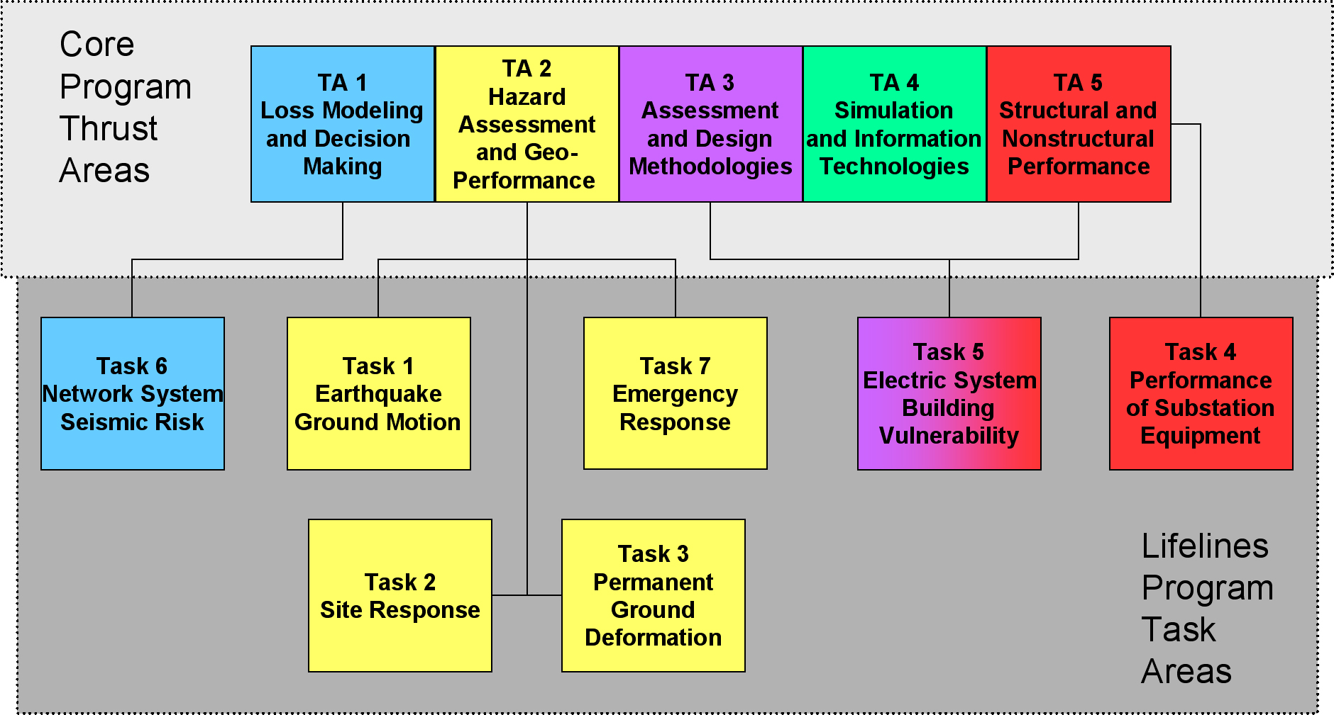
Figure 2: Core and Lifeline programs research relationship graphic (Courtesy of the PEER Center).
Government Code Section §8876.1, requires that the PEER Center conduct research on topics of relevant earthquake engineering research such as:
- Performance-based earthquake engineering for individual buildings, utility, or transportation components.
- Identification of key sources of future earthquake losses, quantification of the sources of risk, and development of strategies for reliably controlling losses.
- Development of cost-effective techniques for the analysis and design of retrofit measures for existing construction.
- Improving techniques for determining the suitability of sites and for understanding critical design relationships among soil conditions, foundations, and structures and for predicting response to earthquake ground motions and earthquake-caused ground failures.
- Experimentation to verify the seismic behavior of bridges, critical communications facilities, utility and transportation system elements, and nonstructural and structural components of buildings.
- Expansion of the database of performance observations from actual earthquakes to ensure that the unfortunate occurrence of earthquakes will also serve the potential societal and scientific purpose of systematically advancing knowledge.
- Encouragement and development emerging technologies, design practices, and analytical capabilities that will offer the potential for breakthroughs in earthquake risk reduction.
- Dissemination of findings to the academic community, design professionals, government officials, building regulatory personnel, and the public.
What were the recommendations and findings from the 2001 Commission Review Report?

In 2001 the Commission reviewed the adequacy of the PEER Center’s efforts during its Year Four (October 2000 through September 2001) review of the PEER Center. The Commission identified the need for the PEER Center to:

- Expand the PEER Center’s industry partnerships to both support and benefit from earthquake technology improvements.

- Develop a better understanding of societal impacts and how public policy decisions are made.

- Inform the public about new developments.

- Train professionals to implement the PEER Center’s findings.

In 2001, the Commission recommended that the State of California:

- Leverage state government funds with support from other government agencies and the private sector.

- Consolidate and encourage better coordination of the State’s management of its earthquake research to reduce piecemeal requests for research and eliminate the variety of overhead rates and special interest driven research.

Major new and continuing activities and projects since 2001

During the reporting period of October 2001 through July 2003 the PEER Center has been working on 150 projects. Two major projects outside of typical PEER projects include working with the Applied Technology Council (ATC) on the evaluation and improvement of procedures for use with performance based engineering methods for seismic design, evaluation and rehabilitation of buildings in the ATC 55 project Evaluation and Improvement of Inelastic Seismic Analysis Procedures. The second effort is the ATC 58 project Performance-Based Seismic Design Guidelines.

The PEER Center sponsored research on data compilation and numerical analysis used in analysis of slope stability. The results of the work was presented to a group of municipal and county agencies in California that were charged with the development of guidelines for practicing engineers to comply with slope stability provisions in the California Seismic Hazard Mapping Act. The guidelines were adopted in 2002 and are now in effect.

A major Lifelines Program project kicked off by the PEER Center is the Next Generation of Attenuation Curves Project. This project is made up of many individual projects in the PEER Lifelines program. The first phase of the project which will update selected current attenuation models, is scheduled for completion by June 2004. It is anticipated that the updated attenuation relations will lower uncertainty levels compared to the current versions, thereby potentially driving down the cost of future structures. This project is expected to be continued in future phases in order to develop new attenuation models. The project will also develop new computer models describing how soil or geologic structure can increase ground motion under certain conditions. This effort uses personnel the PEER Center universities, consultants, the United States Geological Survey, the California Geological Survey, the California Department of Transportation, and the Southern California Earthquake Center.

Continued development of the OpenSees System for Earthquake Engineering Simulation (OpenSees) software for use with advanced earthquake engineering simulations is progressing nicely within the core area of the PEER Center. The software supports the Seismic Performance of Urban region project sponsored by the NSF and is intended to be used in the National Earthquake Engineering Simulation effort. The software is on the Internet and the PEER Center is developing a user base.

All five of the thrust areas within the Core Program of the PEER Center are using OpenSees in modeling various Performance Based Earthquake Engineering activities.

Soil-structure- interaction is where energy and motion is transferred from the soil to a structure or building. This is an area of complex activity during earthquakes. By developing tools to reduce the uncertainty in models for soils structure interaction engineers can better understand the performance of foundation elements, and buildings and structures during earthquakes. The PEER center is creating tools for computing soil structure interaction using the OpenSees platform.
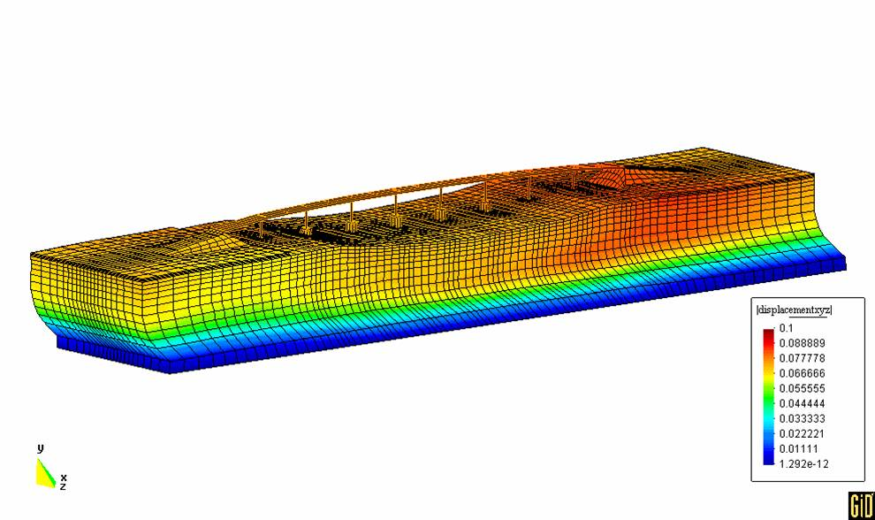
Figure 3: Computer model representation of soil-structure interaction of a bridge using OpenSees.

Within the Lifelines Program, the PEER Advisory Panel of the Inter-Utility Seismic Working Group has been established. The Working Group provides input from several major electric utilities on research needs and the usefulness of current research with respect to their electric transmission and distribution system operations.

In July 2003 the PEER Center hosted the Ninth International Conference on Applications of Statistics and Probability in Civil Engineering in San Francisco. The conference introduced PEER Center activities to engineers from around the world.

The PEER Center is investing a portion of its efforts in social science and public policy research as it relates to earthquake risk and seismic hazard mitigation decision-making.

The PEER Center has held several annual meetings, held tours that included observations of shaking table tests, and sponsored a display at the State Capitol. The PEER Center held a major conference on statistical applications in earthquake engineering in July 2003. One of the more important activities that the PEER Center is engaged in is working with the engineering community to develop guidelines for the use of performance based earthquake-engineering design for buildings.

Since 2001, both the PEER Center and California have made progress on the Commission recommendations. However, State government funds have reduced slightly since 2001. This has had an adverse effect on the level of funding from the NSF since the NSF match monies were reduced by the amount that the State reduced its funding for the PEER Center.

Do we know enough to manage earthquake risk effectively?

No. However, progress is being made. Each major earthquake exposes unsettling surprises. For example, the 1994 Northridge earthquake exposed serious problems in modern steel frame buildings and parking structures.

Without the coordination between the Governor’s Office of Emergency Services, the California Geological Survey, the California Integrated Seismic Network the United States Geological Survey, local governments, and the Seismic Safety Commission, using products such as SHAKE Map and HAZUS loss estimation software, California’s emergency response would degenerate into a wait-and-see attitude at a time within the first few minutes of an earthquake when emergency response is critical. The PEER Center is actively working to use technology to extend the coverage and reliability of ground motion estimates in areas not well covered by instruments to ensure timely identification of areas with potential damage from earthquakes.

The 1989 Loma Prieta earthquake alerted CalTrans to the need to make changes in bridge design and construction practices to ensure safe and reliable transportation. Bridge research and education are helping to make these major changes but similar investments in other sectors of the construction industry have not been made.

Part of the research undertaken by the PEER Center and the Mid-American Earthquake Center is attempting to address the issue of societal impact of earthquakes and seismic hazard mitigation and is looking specifically at what prompts to undertake seismic hazard mitigation for their facilities.

Are earthquake research and education priorities compatible with the public’s needs and priorities?

Yes. Threats from newer, simpler risks occasionally get much more attention and resources than threats from older, more complex risks. The PEER Center’s initial focus is the threat of collapse in older concrete construction, a well-established, complex problem that was identified in the 1971 Sylmar Earthquake. Funding for research and education has come from a variety of sources from the public and private sectors. If these sources worked more closely together to identify their needs and set priorities, the public and the construction industry would benefit from more broadly applicable, cost-effective research. The PEER Center is California’s catalyst for this needed coordination and priority setting.

What can coordinated research and education do for California?

Coordinated education and research can maximize investment made by the funders and benefit society by:

- Collaborating with other government, business, and industry sources on research and education helps ensure that limited funds are allocated to high priority needs and are put into practice. This is becoming more evident as PEER’s collaborative research with MCEER and MAE is transferred into practice.

- Accruing savings in management and overhead costs. Consolidation results in smoother operations.

- Leveraging funds with other sources to create more comprehensive solutions to our needs. This is why the State helped create the PEER Center.

Looking into the near future, NEES should have several world-class pieces of testing equipment come on-line in the fall of 2004. The PEER Center is an active participant supporting NEES. This will allow:

- Access to more and better test equipment;
- Remote monitoring of experiments;
- Sharing of more powerful computer resources not only for PEER members but also with the earthquake engineering community in the United States as a whole.

The bulk of the funding for the new equipment has been obtained from the NSF and is separate from the NSF funding of the PEER Center.

Is the PEER Center’s work consistent with the State’s plans and priorities?

Yes. The PEER Center’s mission supports the California Earthquake Loss Reduction Plan 2002-2006 (SSC 02-02), the State’s official earthquake mitigation plan as well as the California’s Research and Implementation Plan (SSC 94-10). The California Earthquake Loss Reduction Plan 2002-2006 is recognized by the Federal Emergency Management Agency, and calls for:

- Public oversight and priority setting;
- Researchers collaborating with end-users;
- Active participation in research by design professionals;
- Transitioning new knowledge into practice;
- Placing priority on problem-focused research; and,
- Promoting education and outreach.

The PEER Center is working to put these priorities in place. Projects completed or underway in the reporting period of October 2001 through July 2003 involve nine of the eleven elements contained in the 2002-2006 edition of the California Earthquake Loss Reduction Plan (see figure 4). Several of the projects affect more than one element of the California Earthquake Loss Reduction Plan. However, the bar chart shows each of the projects only in one element. As of July 2003, only the Recovery Element of the California Earthquake Loss Reduction Plan has not been a source of research focus by the PEER Center.

California’s Research and Implementation Plan for Earthquake Risk Reduction, 2002 to 2006 (SSC 02-02) recognizes that earthquake engineering is one of three broad areas needing research, education, and technology transfer. California’s Research and Implementation Plan calls for users of research to set priorities for applied, practical results. The PEER Center has created advisory committees and outreach efforts to ensure its research is useful. It has already demonstrated it can work closely with end users like PG&E, the Bay Area Rapid Transit District, and CalTrans in achieving rapid, practical results. During the summer of 2003 the PEER Center’s Lifeline program opened up its joint management committee to members of the Inter-Utility Seismic Hazard Working Group, a group representing by several electric utilities along the west coast.

Research conducted by the PEER Center on the fragility of electric power substation components and development of electric power substation and transmission system models for damage assessment are in agreement with the California Energy Commission’s Draft Five-Year Transmission Research and Development Plan.

Figure 4: Chart of loss reduction elements covered by PEER Center projects in years five & six

- Geosciences
- Research and Technology
- Education and Information
- Economics
- Land Use
- Existing Buildings
- New Construction
- Utilities and Transportation
- Preparedness
- Emergency Response
- Recovery

The total funding for year five and six projects is $11.8 million

How will the PEER Center potentially affect State laws, policies, and building codes?

The PEER Center is affecting state law and policies by obtaining high quality seismic performance information on structures and buildings and related seismic hazard information after earthquakes in a manner that is useful in the development of regulations.

The PEER Center's results are already beginning to make big improvements in the way
structures are evaluated and designed in California. The PEER Center has been able to
identify how certain design methods can lead to collapse in structures shaken by severe earthquakes. This work helped create better ways to design new concrete buildings that will be contained in California's 2006 Building Code. Similarly, the PEER Center's work on electrical equipment has helped lower costs and improve the reliability of qualifying them as earthquake resistant.

The PEER Center also conducts other research that is expected to greatly improve
structural performance and reliability in earthquakes such as:

- Making better ways to describe how the severity of ground motion varies throughout shaken regions
- Generating more realistic computer modeling capabilities that capture the expected behavior of structures
- Providing guidelines for determining hillside stability during earthquakes Improving ways to determine if soft soils near water will liquefy and fail in earthquakes
- Developing more reliable earthquake design methods for common building types
- Monitoring how these new tools are put to use in actual construction projects and using feedback to improve tools

Since performance-based earthquake engineering is a cutting edge concept for both engineers and the general public, the PEER Center's research into how engineers and policymakers can effectively communicate regarding risk decisions has generated several important findings. For example, the PEER Center found that policymakers are less interested in agreeing upon an elusive "acceptable risk". They are much more interested in taking steps toward better safety, particularly if clear regulatory choices with tradeoffs, consequences and cost-effectiveness can be made available. The PEER Center holds workshops to explore and document the linkage between government planning, policies, economics and earthquake safety.

The PEER Center has examined existing policies to look for opportunities for improvement. The PEER Center has found that many failures to enforce building codes have undermined their effectiveness and present a challenge in figuring out how to bring about safer, more reliable construction. There is clearly a pressing need for educating and training building department personnel, designers and contractors. The PEER Center researchers found that earthquake safety considerations are less institutionalized in building departments in the course of doing business and more the apparent subject to the nuances of local resources and pressures. This is partly due to the lack of organized public earthquake constituencies pushing for efforts to avert earthquake losses.

By comparing new PBEE methods to current state-of-the practice design techniques, practitioners and building code officials will be able to validate or propose change to:

- Selected parts of building codes and standards;
- Seismic assessment and mitigation siting and design regulations; and,
- Seismic qualification standards for electrical equipment.

An example of the use of new PBEE techniques verses state-of-the practice is illustrated by comparing measured shear strength to calculated shear strength as shown in figures 5 and 6 below.

Figure 5: Improved ratios of measured shear strengths to estimated shear strengths calculated by PEER Center equations.

Figure 6: Ratios of measured shear strengths to estimated shear strengths calculated by FEMA 273.

The result of constraining the ratio of measured shear strength verses computed shear strength may lead to less variation in building construction costs for similar buildings in similar settings.

How is PEER funded?

The State of California, the NSF, Pacific Gas and Electric Company, and universities (a/k/a academia) provide principal funding for the PEER Center. Additional funding is provided by subscriptions to the PEER Center’s Business and Industry Partnership (BIP) program, but make up less than one per cent of the PEER Center’s funding. The State of California provided for funding of PEER beginning in 1996. Additional State funds became available through CalTrans Research and Technology (cost-sharing of existing PEER Center funding) and Public Interest Energy Research funding provided by the Pacific Gas and Electric Company via a pass through oversight contract on the behalf of the California Energy Commission. Funding from beyond that of the NSF has allowed the PEER Center activities to increase the number and scope of projects performed.

In Year Five (federal fiscal year FFY 2002) the State of California provided 58 per cent of the PEER Center’s support. In year Five, the NSF provided 29 per cent of the PEER Center’s support. This funding level was similar to the average NSF support for the other two earthquake engineering research centers. The balance of the PEER Center’s support came from academia and industry (13 per cent).

In Year Six (federal fiscal year FFY 2003) the State of California provided 36 per cent of the PEER Center’s support. In year six, the NSF provided 48 per cent of the PEER Center’s support. Once again, this funding level was similar to the average NSF support for the other two earthquake engineering research centers. The balance of the PEER Center’s support came from academia and industry (16 per cent).

Occasionally funding availability is delayed due to State or Federal budget issues. The PEER Center carries a small residual of funds from year to year to help ensure work can proceed, in the event that matching funds are not available on schedule.

What is the commitment by the National Science Foundation for continued funding?

On July 30, 2001, the PEER Center announced that the NSF completed its review and approved a second five-year funding cycle. Funds provided by the NSF for operating PEER must be matched by the State of California. This funding commitment by the NSF is through FFY 2006.

What has PEER accomplished in education and outreach?

Progress has been made in the introduction of earthquake engineering problem-solving activities for elementary school students. The development and implementation of lesson plans for elementary school teachers and the use of portable shake tables allow students to build small structures and see if they can withstand scaled down shaking from an imaginary earthquake. A more sophisticated program has been used to attract undergraduate students in earthquake engineering and related fields for graduate school recruitment. Graduate students working on research projects through the PEER Center participate with their advisors on state-of-the-art projects, leading the way to future research and industry applications. The graduate students showcase their projects each year at the PEER Center’s annual meeting. Several students have received their PhDs and are now either working as consultants or have joined the faculties at universities throughout the United States, where they are educating the next generation of urgently needed engineers and scientists.

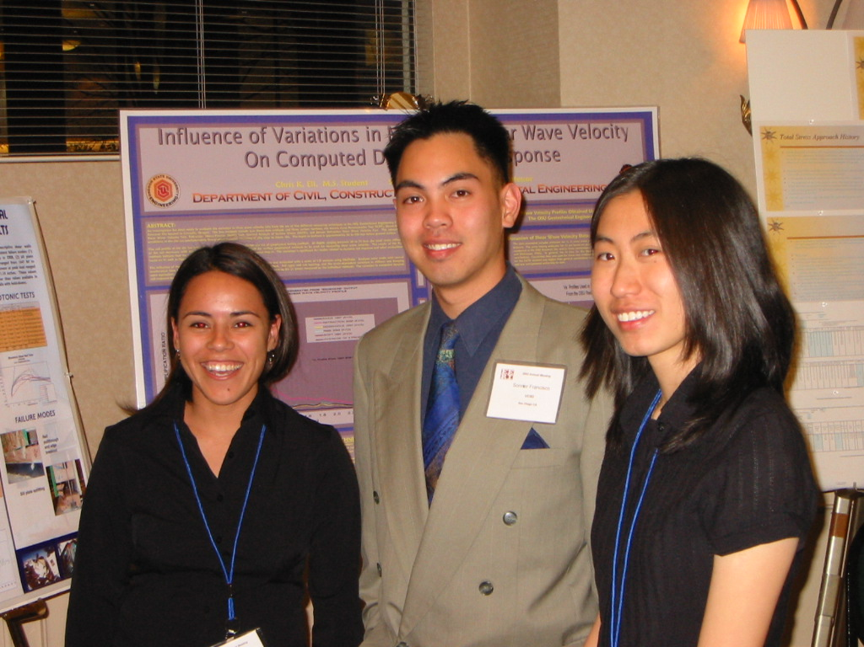
Figure 7: PEER interns who presented research findings at the 2003 earthquake engineering research institute’s annual meeting

Starting in the fall of 1998 the PEER Center began offering a new Earthquake Engineering Scholars Course (EESC) that is a multi-campus program providing instruction to undergraduate students during weekend retreats at PEER campuses. EESC is for seniors in engineering who demonstrate a sincere interest in earthquakes and achieve high academic levels. Each PEER Center core institution has a specified number of Scholars depending on their program size. Scholars from the PEER Center’s affiliate institutions also participated in the course that cover four topics in earthquake engineering:

- Seismology
- Geotechnical Earthquake Engineering
- Structural Dynamics in Engineering, and
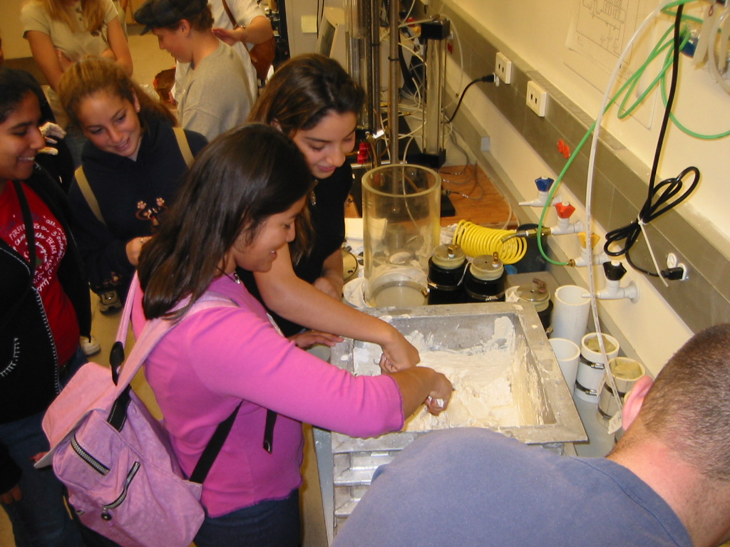
- Public Policy

Figure 8: Middle school students preparing a sample for a shaking table experiment.

The PEER Center works with the California Academy of Sciences Natural History Museum in San Francisco to enhance its earthquake exhibit, thereby better educating the public on reducing earthquake losses. Recently PEER Center researchers have been working with inner city teachers and elementary and secondary school students. The students have prepared science fair projects after visiting one of the PEER Center member or affiliate universities. Several of the projects have been entered in local science fairs by the students and have done quite well.

Report preparation and acknowledgements

This report was prepared by the California Seismic Safety Commission’s PEER Center Review Committee consisting of Chairperson Mr. Linden T. Nishinaga, Dr. Lucile Jones, Mr. Lawrence Klein, Mr. Daniel Shapiro, Mr. Stan Moy, and Mr. Lloyd Cluff (from the Pacific Gas and Electric Company); and Ms. Susan Tubbesing (from the Earthquake Engineering Research Institute); and by Commission staff Mr. Robert Anderson, Mr. Richard McCarthy, Mr. Fred Turner, Mr. Henry Sepulveda, and Ms. Sue Celli.

The Commission thanks Dr. Jack Moehle and his staff from the PEER Center for their cooperation in the preparation of this report.

For further information regarding this report please contact Mr. Anderson at (916) 263-5505 or e-mail at: banderson@quiknet.com. Further information on the PEER Center may be found at the website: http://peer.berkeley.edu/.

Publication information

Report No. SSC 03-04
California Seismic Safety Commission
1755 Creekside Oaks Drive, Suite 100
Sacramento, California 95833
Telephone: (916) 263-5506
Fax: (916) 263-0594
E-mail: scelli@quiknet.com

Complies with the Library Distribution Act and California Govt. Code Section 11096



